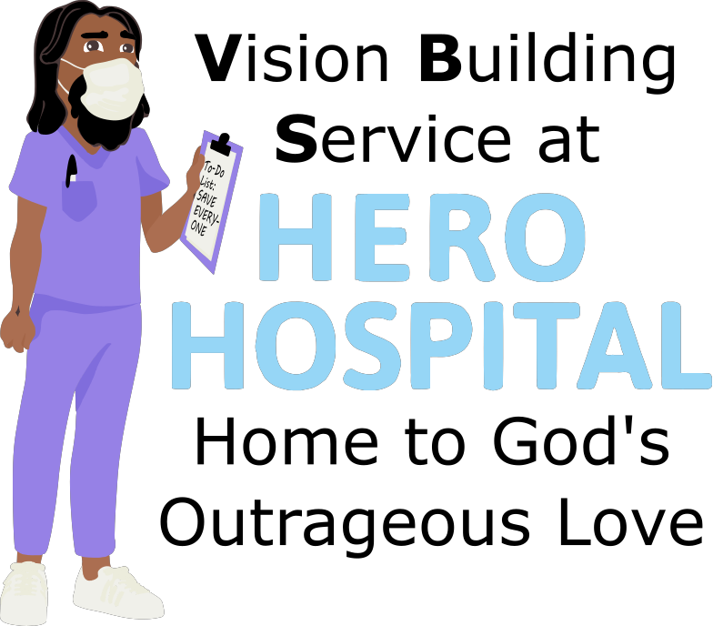
This week at Hero Hospital, we'll be learning that God's Kingdom is a
place for Hope!
Instructions for activities are found at: bannerblue.org/herohospital
In Story, we'll learn from our historical guide Fabiola and hear how Jesus inspired hope by bringing people together!
Provided Supplies: Builder Book and Builder Bricks.

In Science, we'll investigate the science behind real dollars and cents.
Provided Supplies: Builder Book and Builder Bricks, paper, pencil, strong magnet (we gave everyone magnets at VBS last year, if you do not have a magnet let us know and we’ll get you one).
Supplies from Home: Variety of paper and coin currency, flashlight, magnifying glass (you can use the zoom on your phone camera as a magnifying glass).
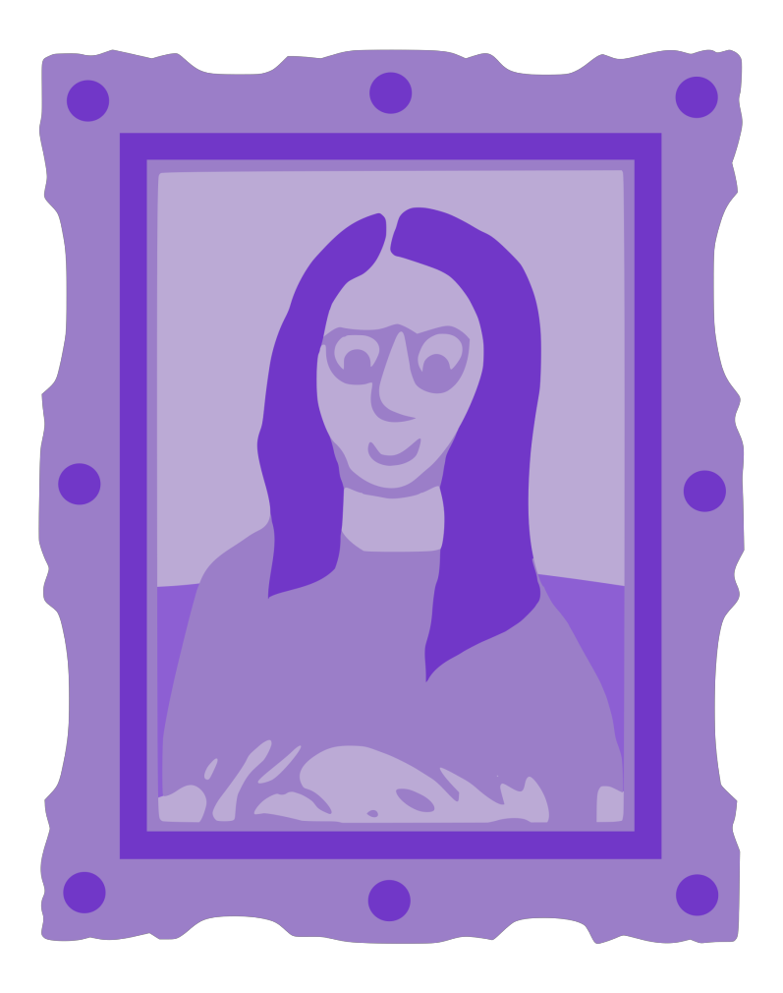
In Art, we’ll redesign a $10,000 Bill and make a giant check.
Provided Supplies: Builder Book and Builder Bricks, markers, $10,000 Bill Template, Giant Check Template, magazines.
Supplies from Home: glue, scissors.
In Games, we’ll put a fun spin on Uno or Monopoly by using the Gospel Rules! Or you can find a creative version of tag on the website.
Provided Supplies: Builder Book and Builder Bricks.
Supplies from Home: Uno or Monopoly.

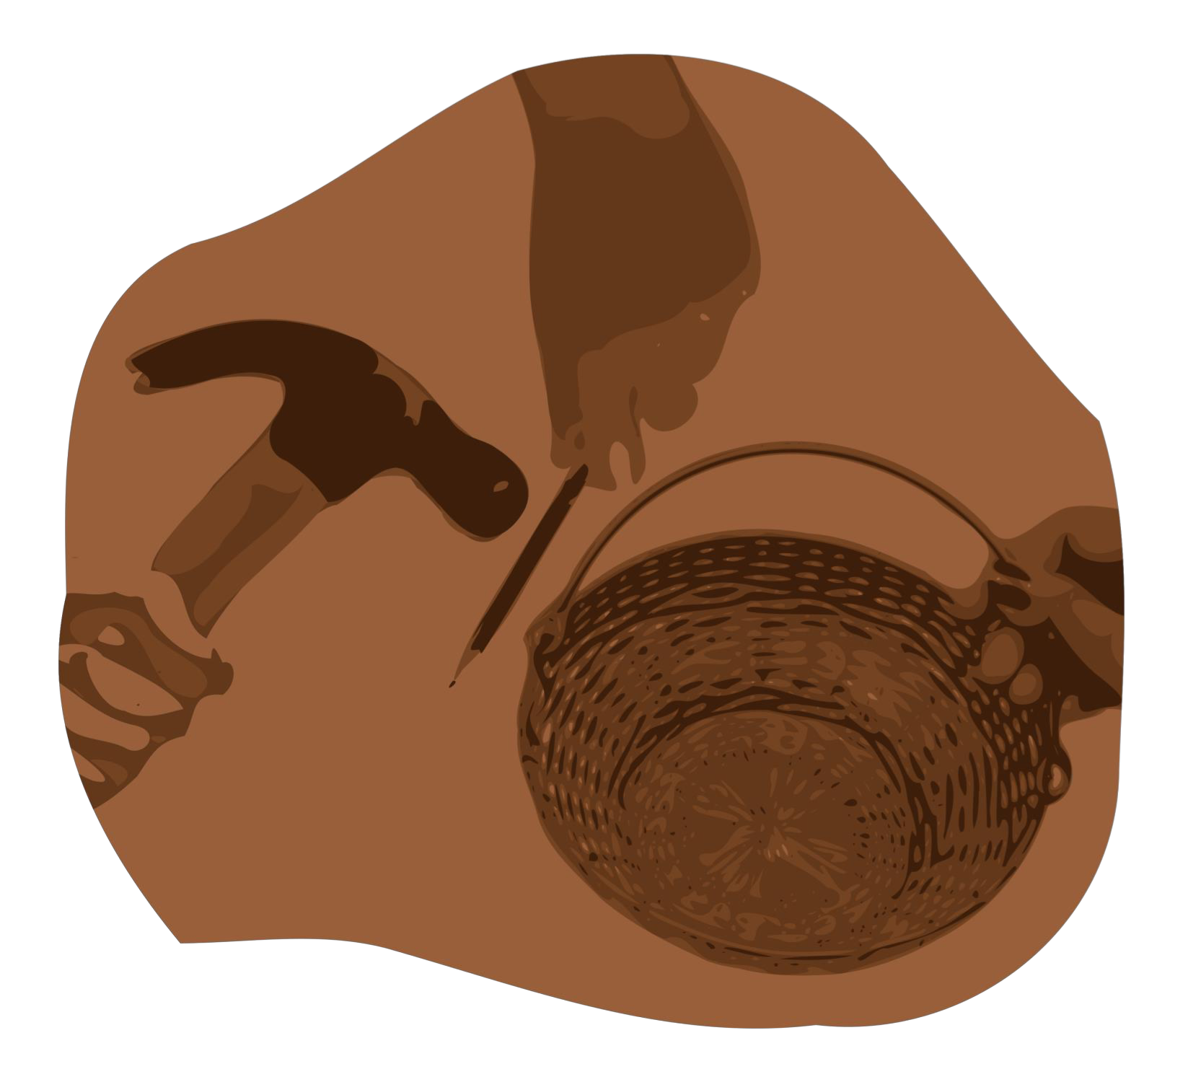
After learning about how Jesus wants us to make the world a better place by living out our faith, we’ll be inspired to do a Big Church Project! This week we’ll be inspired to raise money to help end medical debt. Kids are invited to ask Pastor Katie about this when they return next week!
Provided Supplies: Builder Book and Builder Bricks.
During Worship we’ll sing and dance along with our VBS Music. Kids can also listen to the Music on the Hero Hospital website.
Provided Supplies: Builder Book and Builder Bricks.

After sharing all of these activities and learning about faith during worship and at home with their families, our kids will be able answer this week’s Big Question: What should you do if you experience an illness or disability?
Provided Supplies: Builder Book and Builder Bricks.

Remember to bring back your finished art and science activities for Show and Tell!

