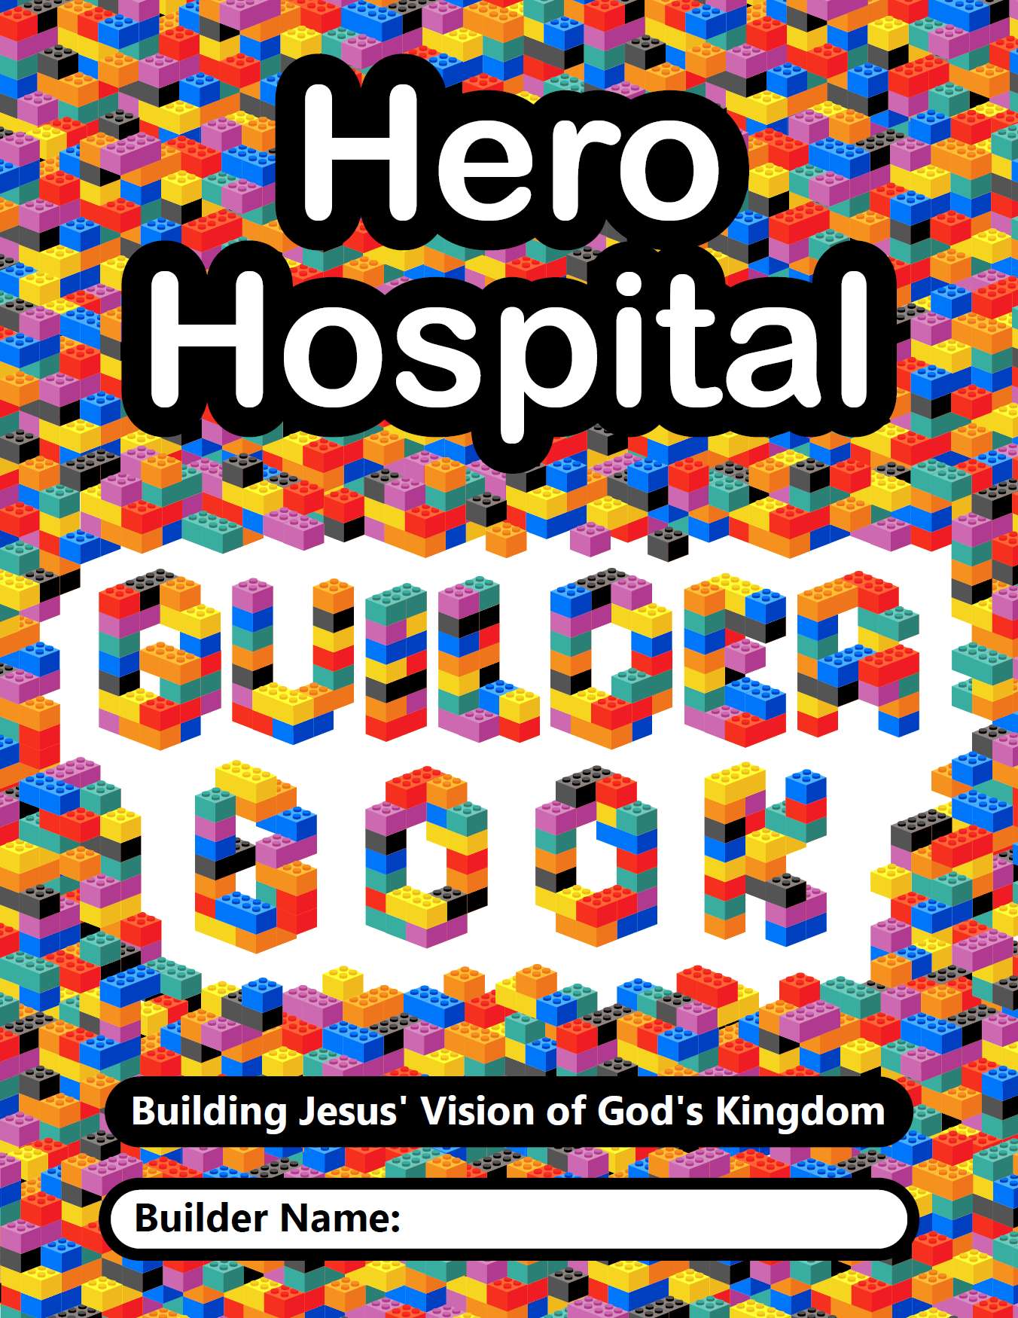

Table of Contents
Part One: Building a Place for All | Page 1
Part Two: Building a Place for Heroes | Page 11
Part Three: Building a Place for Hope | Page 21
I’m Awesome Pages | Middle of Book
Part Four: Building a Place for Healing | Page 31
Part Five: Building a Place for Discovery | Page 41
Part Six: Building a Place for Praise | Page 51

Each part of the book contains the following elements:
- Intro to the Part
- Historical Guide Story
- Historical Guide “Awesome” page (for placing stickers)
- Jesus’ Story
- Your Story (for placing stickers on “I’m Awesome” pages)
- Let’s Get Scientific (for connecting with online science experiment)
- Let’s Get Artistic (for connecting with online art project)
- Let’s Play a Game (for connecting with online Gospel Rules)
- Let’s Change the World (for connecting with Big Church Project and answering Big Question)
Building a place for…
It’s time to learn about Ella and her story as well as Jesus and his story. Check out the graphic on the next page or bannerblue.org/herohospital. Once you have learned about Ella, award her Builder Bricks by putting stickers on the Susan’s Awesome page (3) for all the things she did to build up Jesus’ vision of the Kingdom of God.
Bricks may be awarded for things like this:
 | One brick for every example from the story about music.
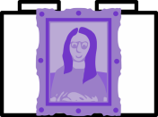 | One brick for every example of making something or being creative.
 | One brick for every example of learning and exploring ideas.
 | One brick for being a good example and leading the way.
 | One brick for accomplishing something new in life.
 | Two bricks for working to include others.
 | One brick for anything else you can think of.
Ella P. Stewart’s Story
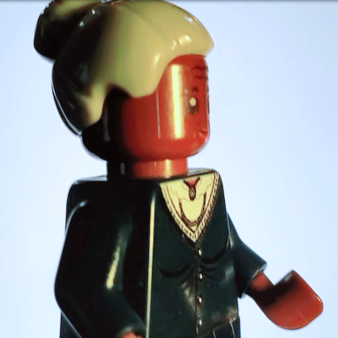 | African American  Ella was born in 1892 in Virginia, U.S.A. |  | 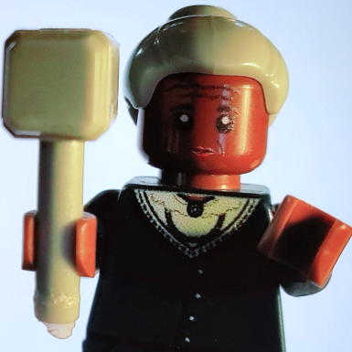 | Girl  Ella had three siblings and was  the oldest.
Christian  Ella was a leader in  her church and  helped to bring churches together  for big projects. |  | 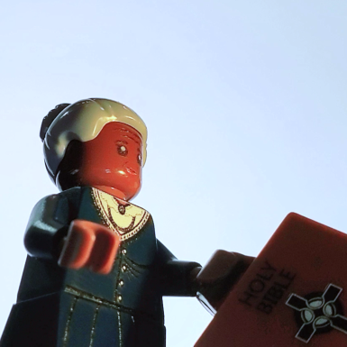 | First Black Pharmacist in America  Ella went to school when being a girl and being black made it really hard. |  | 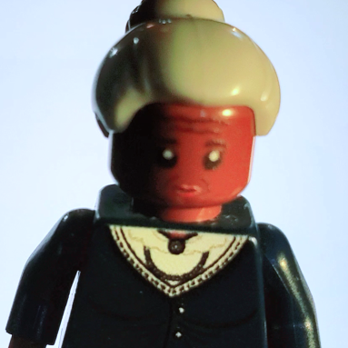
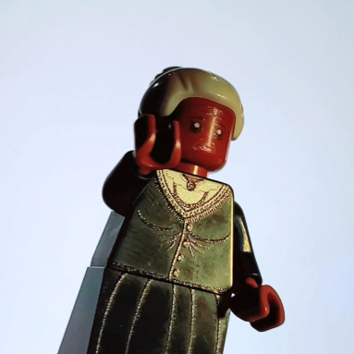 | Started a Pharmacy  Ella worked hard to make sure that everyone in her town could get the medicine they needed. |  | 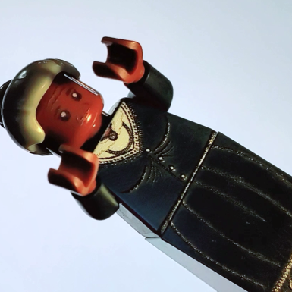 | Led NACW  Ella was president of a national group helping women of color to be able to go to the same places and to have the same rights as everyone.
Led PPSEWA  Ella was vise-president of a group helping women in Asia and the Pacific Islands be included in making peace. |  | 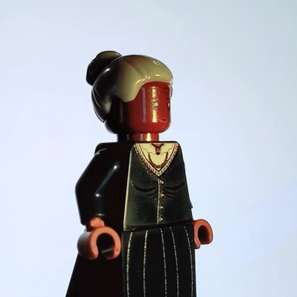 | Led UNESCO  Ella was commissioner or leader for a worldwide group working to heal the world with peace. |  | 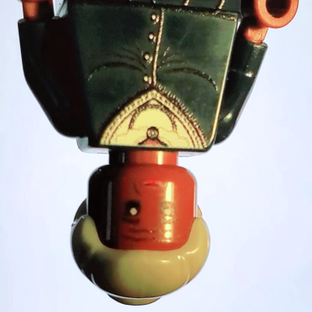
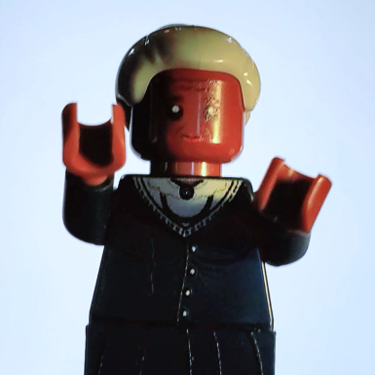 | Proud of Her School  Ella loved to visit the school that was named after her - Go Panthers!!! |  | 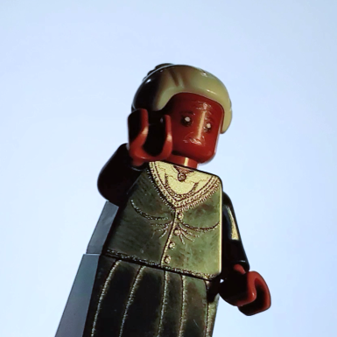 | Loved to See New Places  Ella travelled all over the United States and even the world but called Ohio home.
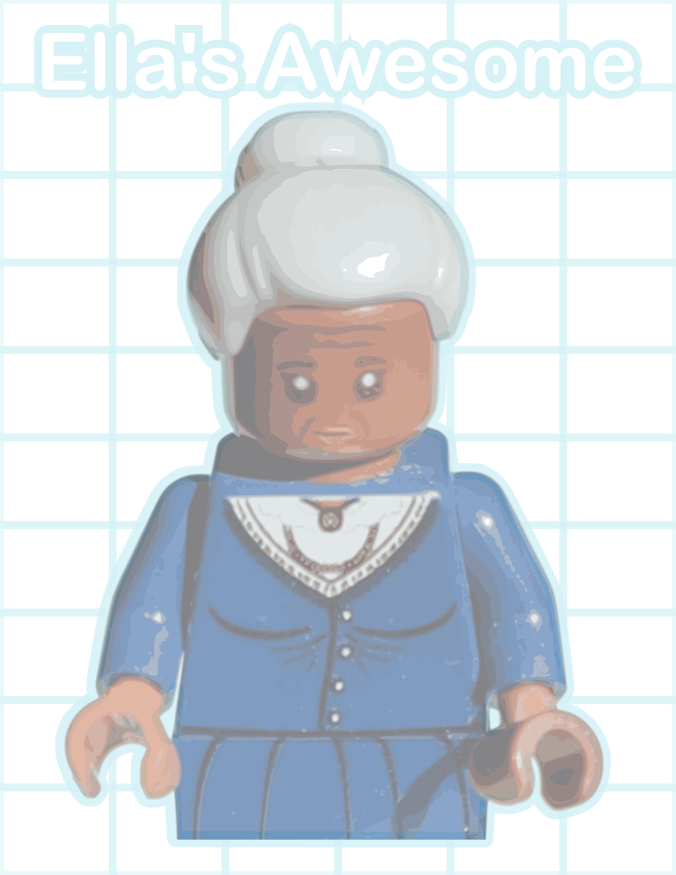

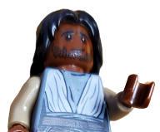
Jesus’ Story
“They rubbed their eyes, amazed—and then glorified God, saying, “We’ve never seen anything like this!” From Mark 2:1-12
One day Jesus was talking to a crowd at a house and the place was overflowing with people. | 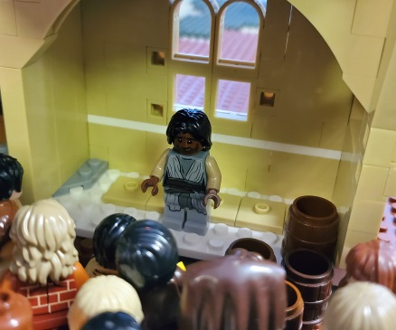 |  | A man who lived with paralysis was with four friends and there was no way they could get inside. | 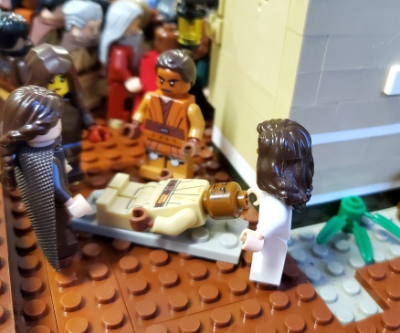
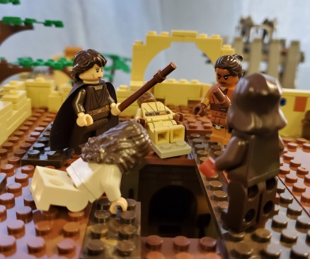 |  | They climbed onto the house’s roof and dug a hole through to the inside. | 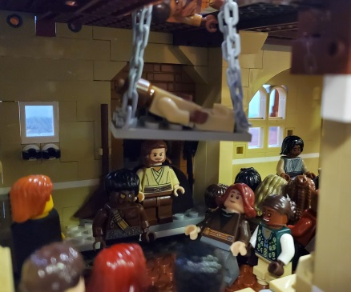 |  | The man with paralysis was lowered down to Jesus.
Jesus’ was thrilled they worked together so hard just to see him, and told the man he had all of God’s love. | 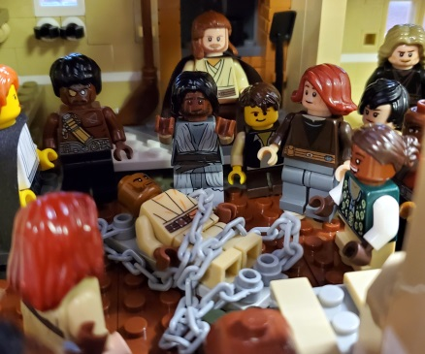 |  | People questioned whether Jesus was allowed to share God’s love. | 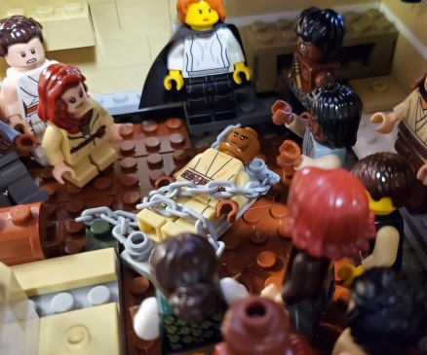
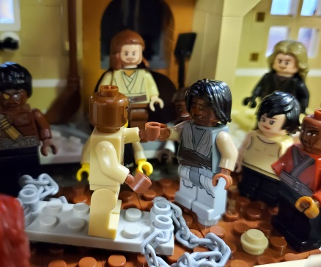 |  | Jesus answered by taking away the man’s paralysis. | 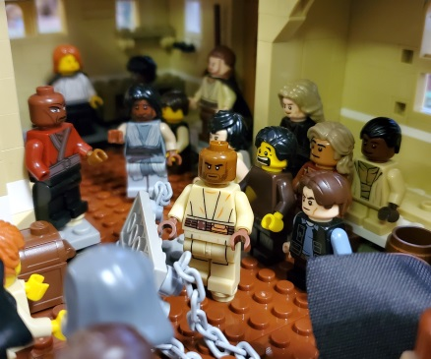 |  | The man stood up, picked up his mat, and the crowd split as he walked out to be with his friends.
There were so many people around Jesus that the only way to get to him was to literally dig a hole through the roof. A bunch of friends did just that so that a man living with paralysis could reach Jesus. Jesus was so happy to show how this man was included in God’s love.
Your Story
Now it’s time to award Builder Bricks to yourself and your friends. How many ways can you connect to Jesus’ or Ella’s story? What are gifts you have and things you do to help build Jesus’ vision of God’s Kingdom?
Go to your “I’m Awesome” pages (they’re in the middle of the builder book) and award bricks for things like this:
One brick for every example from the story about music.
One brick for every example of making something or being creative.
One brick for every example of learning and exploring ideas.
One brick for being a good example and leading the way.
One brick for accomplishing something new in life.
Two bricks for doing something to praise God like Ella.
Two bricks for following Jesus and helping people like he did.
One brick for any other way that Ella is like you or you are like her.
Let’s Get Scientific!!!
Before you complete the Part One science experiment, write down your hypothesis about what will happen:
If I use my imagination and skills to try to build a prosthetic, I will…
_______________________________________________________________________
_______________________________________________________________________
_______________________________________________________________________
_______________________________________________________________________
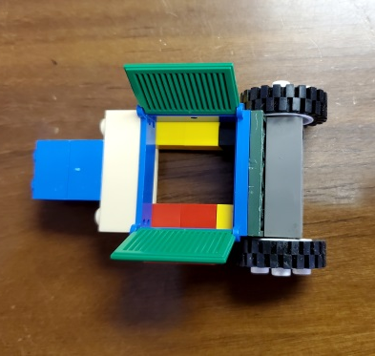
Now complete the investigation into The Power of Prostheses using the online guide at bannerblue.org/herohospital.

Next write about what will happen if you use your imagination and skills as a builder of Jesus’ vision of God’s Kingdom:
If I’m making our church into a place for all people, we will…
_______________________________________________________________________
_______________________________________________________________________
_______________________________________________________________________
_______________________________________________________________________
Give yourself a on your “I’m Awesome” pages for investigating.
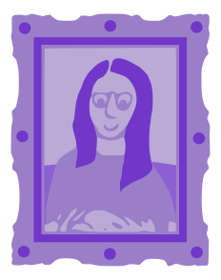
Let’s Get Artistic!!!
Before you complete the Part One art project, draw some ideas to help get you started:
If I use my imagination and skills to try to create a Pocket Prayer Quilt, it might look something like this…

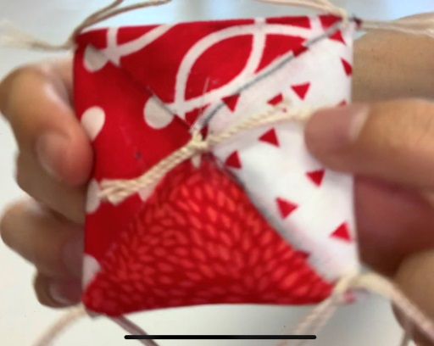
Now work on the Pocket Prayer Quilt using the online guide at bannerblue.org/herohospital.

Next draw what will happen if you use your imagination and skills as a builder of Jesus’ vision of God’s Kingdom:
If I’m making our church into a place for all people, we will…

Give yourself a on your “I’m Awesome” pages for creating.
Let’s Play a Game!!!
Have fun with family or friends using the
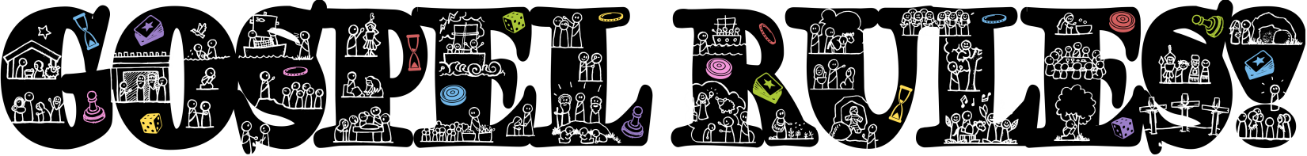
for Guess Who or Celebrities.
Find these rules and an alternate tag game on bannerblue.org/herohospital.
Give yourself a on your “I’m Awesome” pages for playing.
Let’s Change the World!!!
Starting in Your Own Community
You’ve been working hard using your imagination and skills to build Jesus’ vision of God’s Kingdom. The leaders at your church should be doing that too! You all have been given a Big Church Project. It’s time for you to be a leader in making that project happen!

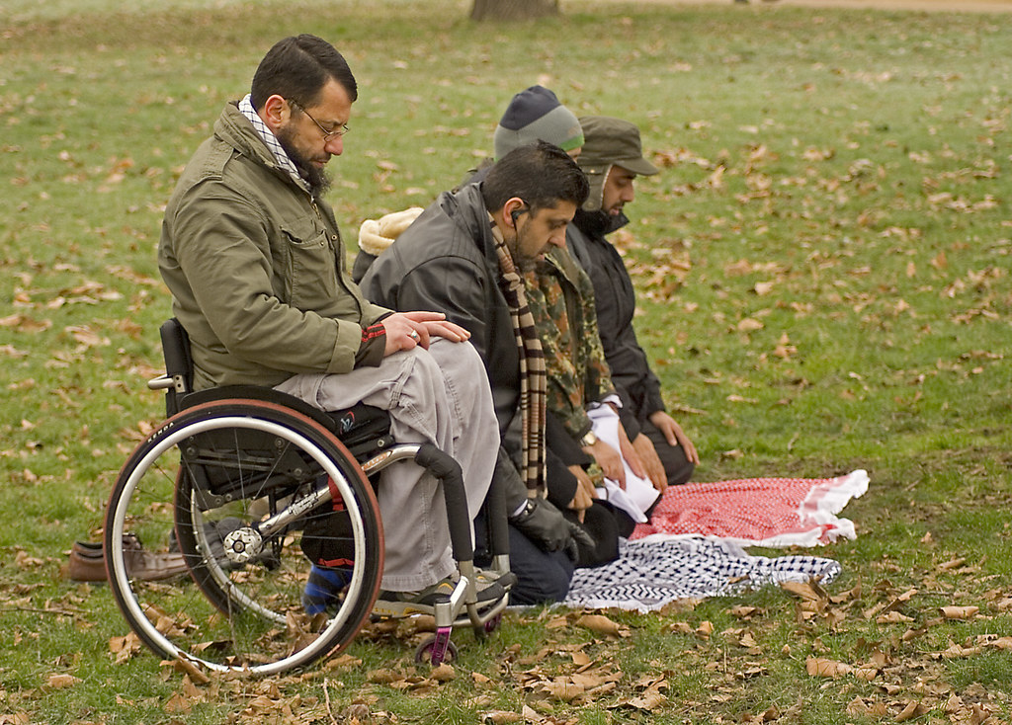
Ask your Pastor and Council President what they’re doing to Develop Person-first Language for your church’s prayers and other communications. Learn more at bannerblue.org/herohospital.

You’re getting so smart! It’s time to answer the big question:
Does experiencing an illness or disability define all of who you are?
_______________________________________________________________________
_______________________________________________________________________
_______________________________________________________________________
_______________________________________________________________________
You are already building a place for all within Jesus’ vision of God’s Kingdom. From Mark 2:1-12 we hear the good news, “They rubbed their eyes, amazed—and then glorified God, saying, “We’ve never seen anything like this!” Take things to the next level by answering this open-ended question:
What are the best words you can use to describe someone so that she knows God loves her?
Do you use those words at church?
_______________________________________________________________________
_______________________________________________________________________
_______________________________________________________________________
_______________________________________________________________________
Give yourself a on your “I’m Awesome” pages for building.
Building a place for…
It’s time to learn about Harriet and her story as well as Jesus and his story. Check out the graphic on the next page or at bannerblue.org/herohospital. Once you have learned about Harriet, award her Builder Bricks by putting stickers on the Harriet’s Awesome page (13) for all the things she did to build up Jesus’ vision of the Kingdom of God.
Bricks may be awarded for things like this:
One brick for every example from the story about music.
One brick for every example of making something or being creative.
One brick for every example of learning and exploring ideas.
One brick for being a good example and leading the way.
One brick for accomplishing something new in life.
Two bricks for overcoming hardship with courage.
One brick for anything else you can think of.
Harriet Tubman’s Story
African American  Harriet was born in 1822 in Maryland, U.S.A. | 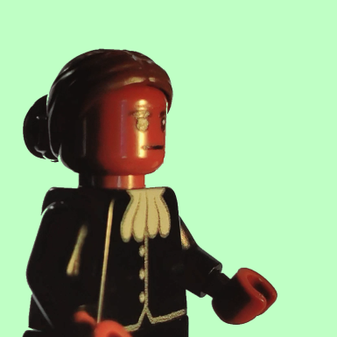 |  | Girl  Harriet had eight siblings and was the middle child. | 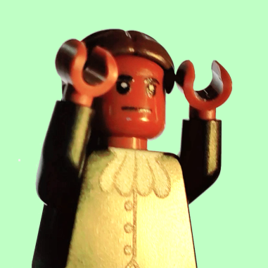
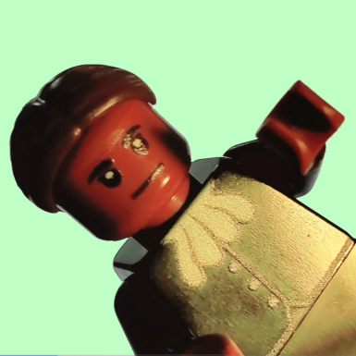 |  | Jumped In to Save Someone  When Harriet was only a kid, she jumped in front of a slave master who was throwing a metal weight at another slave. | 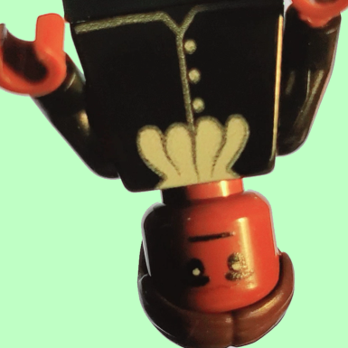 |  | Lived with a Disability  Harriet was hit hard in the head by a slave master and lived her whole life with crippling headaches and maybe even epilepsy.
Escaped Slavery  Harriet led herself and others on a daring escape from their slave master, reaching freedom. | 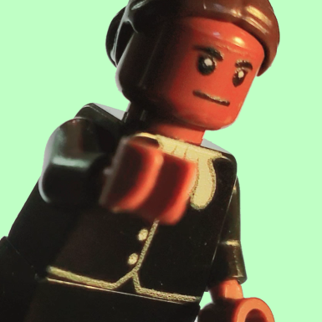 |  | Civil War Nurse  Harriet served in the Civil War as a nurse helping wounded soldiers on the battlefield. | 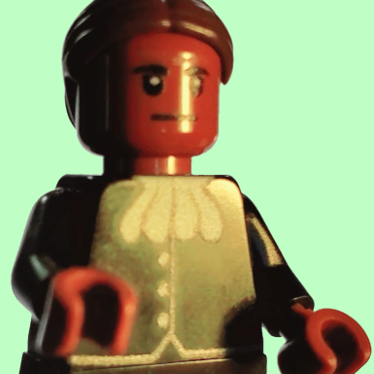
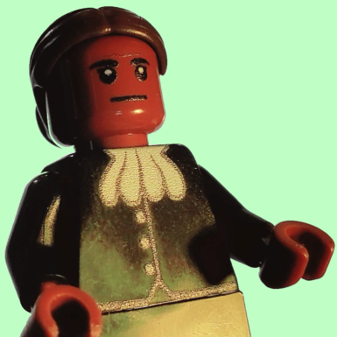 |  | Civil War Spy  Harriet became a spy for the Union Army, helping soldiers to win the war against slavery. | 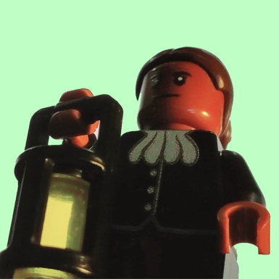 |  | Conductor on The Underground Railroad  Harriet led crowds of people out of slavery, passing through many towns and forests on the way to freedom.
Fearless  Faith made Harriet Tubman fearless in the face of certain danger because she knew she was following God’s path, people even called her “Moses.” | 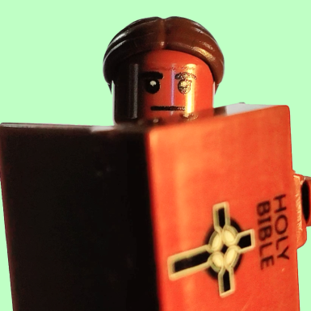 |  | Spiritual Songs  Harriet and others sang amazing songs called Spirituals to keep their hopes up and to communicate. | 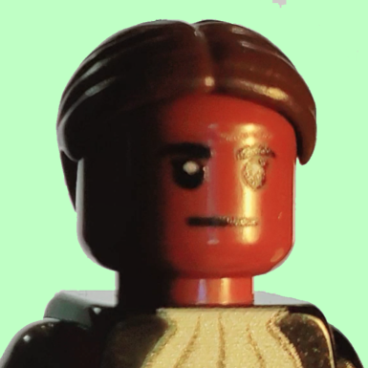
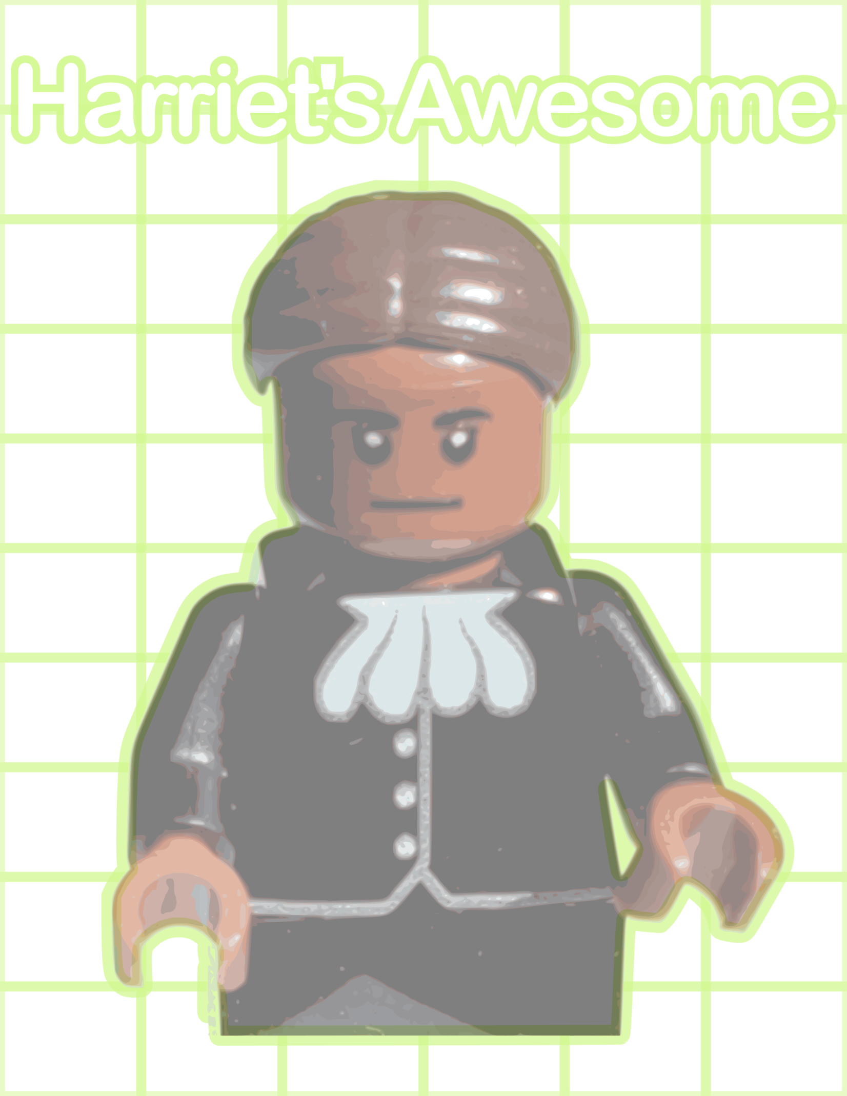

Jesus’ Story
“He taught people the truth of God—the good news of the kingdom. Word got around. Jesus healed them, one and all.” From Matthew 4:19-25
Jesus saw some people fishing and said, “Follow me and I will make you fish for people.” | 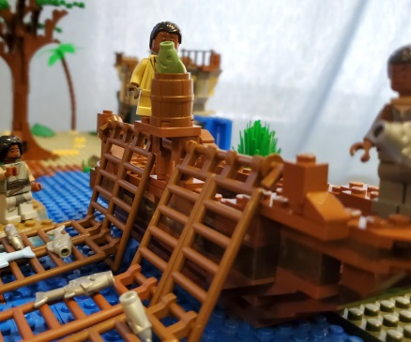 |  | They had heard of the amazing Jesus, so they dropped their nets and became his disciples. | 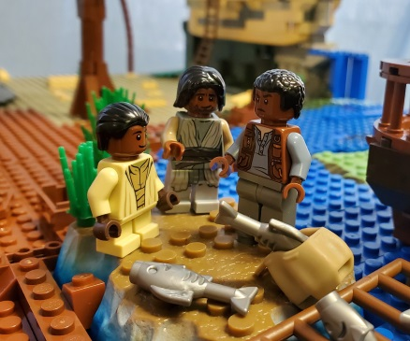
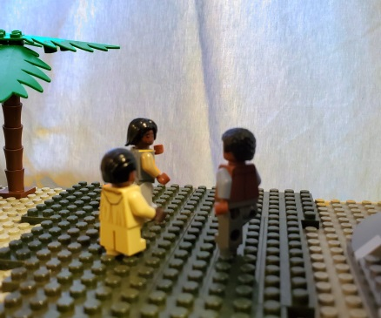 |  | They followed Jesus as he travelled around healing and proclaiming the good news of God’s kingdom. | 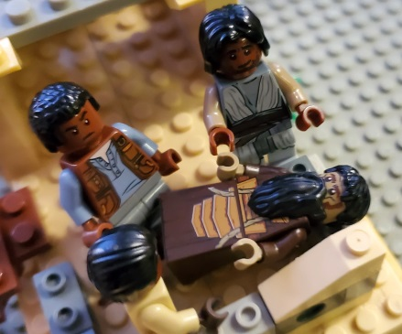 |  | He helped people who lived with diseases.
He helped people who lived with mental illness. | 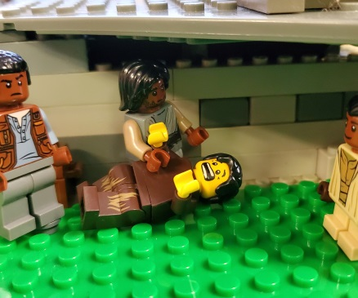 |  | He helped people who lived with disabilities. | 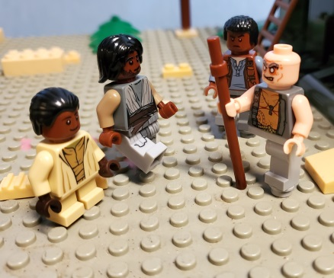
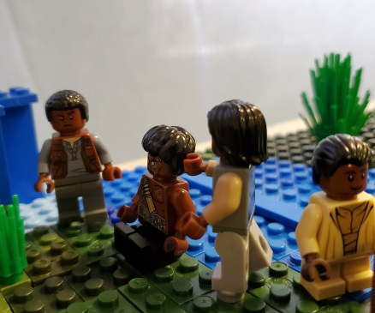 |  | He helped people who lived with blindness or deafness. | 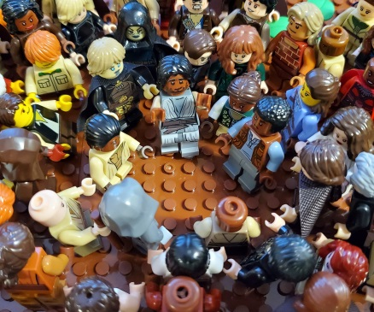 |  | Jesus became a hero. The crowds of people who decided to follow him got bigger and bigger.
You can also watch the video of this story at bannerblue.org/herohospital.
Jesus’ brand-new disciples watched as he helped people in whatever way they needed to be and feel better. Since pretty much everybody needs help in some way, everyone started to follow Jesus.
Your Story
Now it’s time to award Builder Bricks to yourself and your friends. How many ways can you connect to Jesus’ or Harriet’s story? What are gifts you have and things you do to help build Jesus’ vision of God’s Kingdom?
Go to your “I’m Awesome” pages (found in the middle of the Builder Book) and award bricks for things like this:
One brick for every example from the story about music.
One brick for every example of making something or being creative.
One brick for every example of learning and exploring ideas.
One brick for being a good example and leading the way.
One brick for accomplishing something new in life.
Two bricks for doing something heroic like Harriet.
Two bricks for following Jesus and helping people like he did.
One brick for any other ways you’re like Harriet or she’s like you.
Let’s Get Scientific!!!
Before you complete the Part Two science experiment, write down your hypothesis about what will happen:
If I use my imagination and skills to try to build a hovercraft, I will…
_______________________________________________________________________
_______________________________________________________________________
_______________________________________________________________________
_______________________________________________________________________
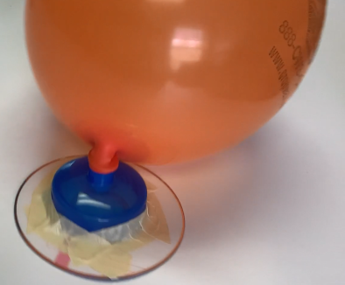
Now complete the investigation into Hovering Over It All using the online guide at bannerblue.org/herohospital.

Next write about what will happen if you use your imagination and skills as a builder of Jesus’ vision of God’s Kingdom:
If I’m making our church into a place for heroes, we will…
_______________________________________________________________________
_______________________________________________________________________
_______________________________________________________________________
_______________________________________________________________________
Give yourself a on your “I’m Awesome” pages for investigating.
Let’s Get Artistic!!!
Before you complete the Part Two art project, draw some ideas to help get you started:
If I use my imagination and skills to try to create Inner Strength Tattoo Stamps, they might look something like this…

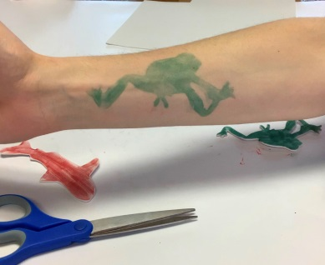
Now work on the Inner Strength Tattoo Stamps using the online guide at bannerblue.org/herohospital.

Next draw what will happen if you use your imagination and skills as a builder of Jesus’ vision of God’s Kingdom:
If I’m making our church into a place for heroes, we will…

Give yourself a on your “I’m Awesome” pages for creating.
Let’s Play a Game!!!
Have fun with family or friends using the
for Guess in 10 or Pictionary.
Find these rules and an alternate tag game on bannerblue.org/herohospital.
Give yourself a on your “I’m Awesome” pages for playing.
Let’s Change the World!!!
Starting in Your Own Community
You’ve been working hard using your imagination and skills to build Jesus’ vision of God’s Kingdom. The leaders at your church should be doing that too! You all have been given a Big Church Project. It’s time for you to be a leader in making that project happen!
Ask your Pastor and Council President what they’re doing to Hold a “Care for Returning Veterans Workshop” or similar learning experience about trauma and mental health from a group like NAMI. Learn more at bannerblue.org/herohospital.
You’re getting so smart! It’s time to answer the big question:
What should you do if your friend experiences an illness or disability?
_______________________________________________________________________
_______________________________________________________________________
_______________________________________________________________________
_______________________________________________________________________
You are already building a place for heroes within Jesus’ vision of God’s Kingdom. From Matthew 4:19-25 we hear the good news, “He taught people the truth of God—the good news of the kingdom. Word got around. Jesus healed them, one and all.” Take things to the next level by answering this open-ended question:
Do you feel like the pandemic will ever really end?
Who are the people who are helping to make that happen?
_______________________________________________________________________
_______________________________________________________________________
_______________________________________________________________________
_______________________________________________________________________
Give yourself a on your “I’m Awesome” pages for building.
Building a place for…
It’s time to learn about Fabiola and her story as well as Jesus and his story. Check out the graphic on the next page or at bannerblue.org/herohospital. Once you have learned about Fabiola, award her Builder Bricks by putting stickers on the Fabiola’s Awesome page (23) for all the things she did to build up Jesus’ vision of the Kingdom of God.
Bricks may be awarded for things like this:
One brick for every example from the story about music.
One brick for every example of making something or being creative.
One brick for every example of learning and exploring ideas.
One brick for being a good example and leading the way.
One brick for accomplishing something new in life.
Two bricks for bringing hope to others.
One brick for anything else you can think of.
Saint Fabiola’s Story
Roman Noble  Fabiola was born in the 300s CE in Rome, capital of the Roman Empire (now Italy). | 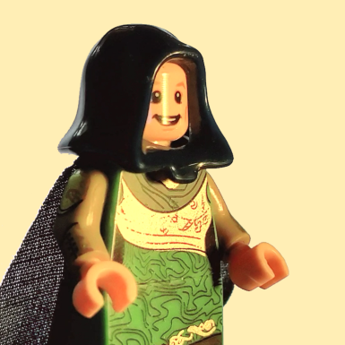 |  | Girl  We are not sure if Fabiola had any siblings but it’s possible she was an only child.
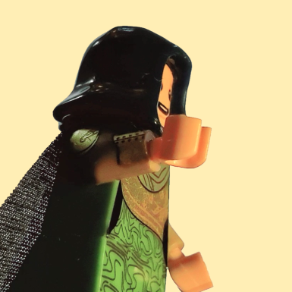 |  | Went to Church  Fabiola spent lots of her time attending and helping out at church. | 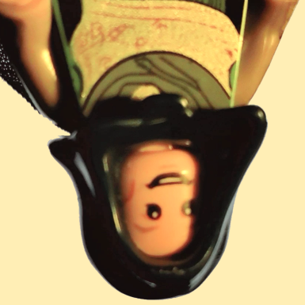 |  | Friends from a Different Country  Fabiola was friends with Saint Jerome who lived in Syria in the Middle East and she was friends with Saint Augustine who was African.
Lost a Loved One Fabiola’s husband died and she missed him very much but never lost hope. | 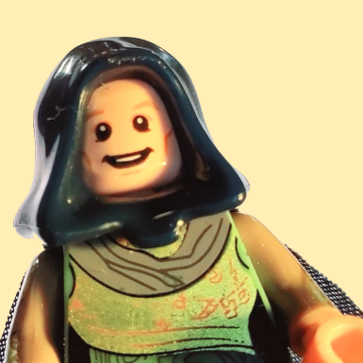 |  | Started First Hospital Fabiola gave the money to build and helped to design the first public hospital in the whole world. | 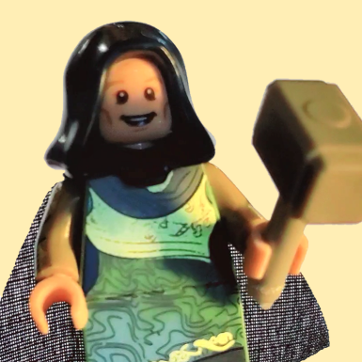
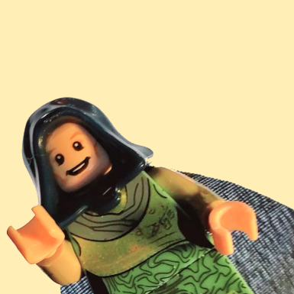 |  | Volunteered  Fabiola volunteered a lot at her hospital and cared for the sick personally. |  |  | Gave Hope to Many Many people came searching for Fabiola’s hospital because they knew that any person could find help there.
Advocated for Change  Fabiola worked with her friends to make sure that powerful people made the right decision to build many many more hospitals. |  |  | Called a Saint  Fabiola has the title Saint because her faith has brought hope and inspiration to countless people. | 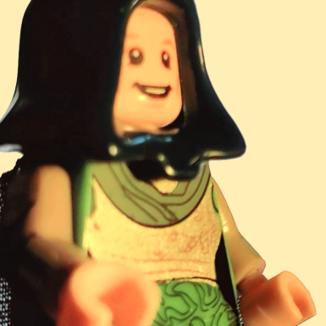
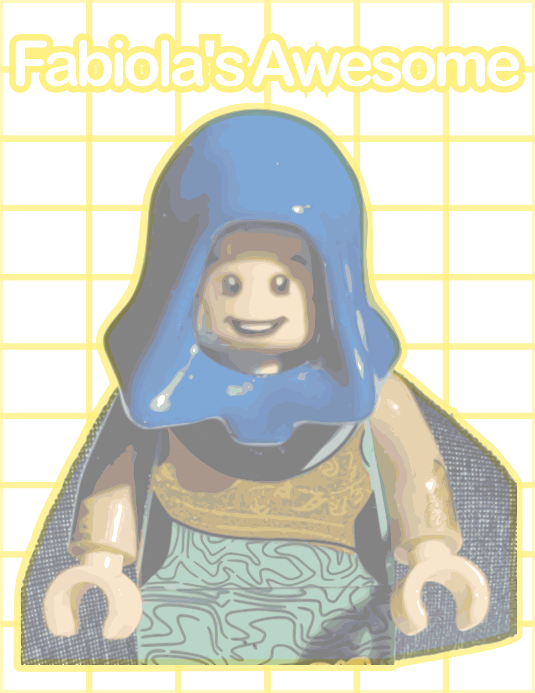

Jesus’ Story
Jesus said, “Daughter, now you’re healed and whole. Go in Peace. Live well, live blessed!”
from Luke 8:40-56
One day, a person named Jairus came to Jesus about his sick daughter. | 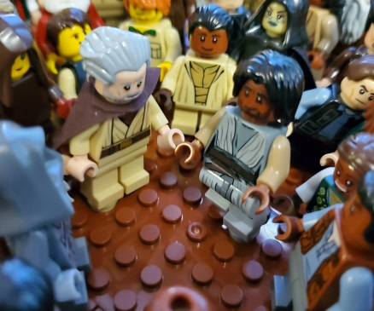 |  | Jesus tried to  go to the house but the crowds were pressing  in on him. | 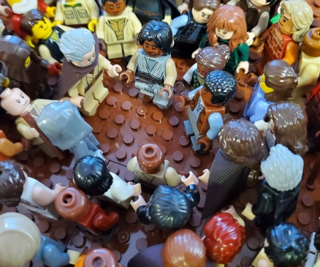
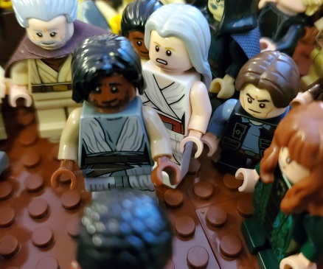 |  | An older woman  who hadn’t stopped bleeding for 12 years squeezed through, touched Jesus’ cloak, and was healed. | 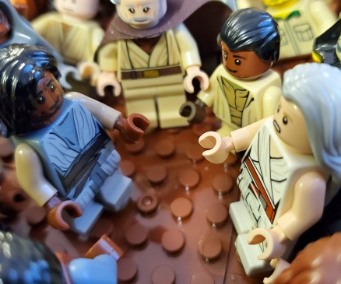 |  | Jesus asked who he just healed and the woman spoke up. He sent her home in peace, saying that it was her own faith that made her well.
Suddenly, someone shouted out that the little girl Jesus was on his way to help had just died. | 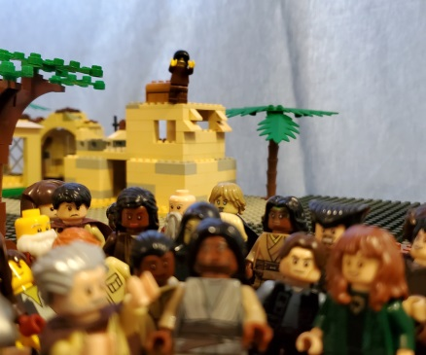 |  | Jesus said not to worry, she would be fine, but the people laughed at him. | 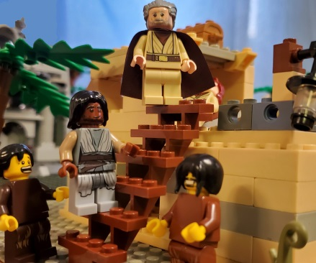
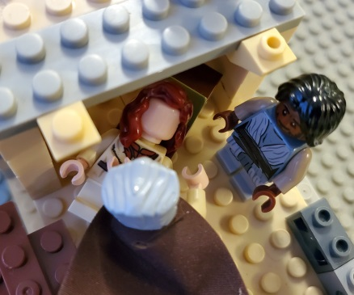 |  | Jesus went to the girl’s dead body, took her by the hand and asked her to get up. | 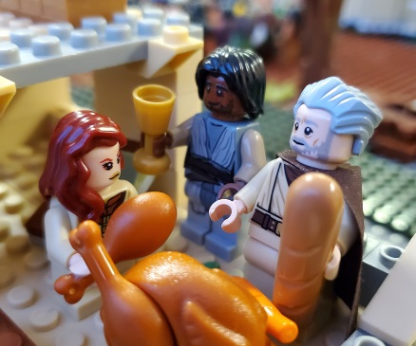 |  | She came back to life and they gave her something to eat because she was pretty hungry.
You can also watch the video of this story at bannerblue.org/herohospital.
A woman in a lot of pain was afraid to ask for help so she just wanted to get close to Jesus. Touching his cloak healed her. Jesus was so happy he had helped her. He continued to bring a little girl back from the dead even though the people didn’t think he could do it.
Your Story
Now it’s time to award Builder Bricks to yourself and your friends. How many ways can you connect to Jesus’ or Fabiola’s story? What are gifts you have and things you do to help build Jesus’ vision of God’s Kingdom?
Go to your “I’m Awesome” pages (found in the middle of your Builder Book) and award bricks for things like this:
One brick for every example from the story about music.
One brick for every example of making something or being creative.
One brick for every example of learning and exploring ideas.
One brick for being a good example and leading the way.
One brick for accomplishing something new in life.
Two bricks for doing something to bring hope like Fabiola.
Two bricks for following Jesus and helping people like he did.
One brick for any other way you’re like Fabiola or she’s like you.
Let’s Get Scientific!!!
Before you complete the Part Three science experiment, write down your hypothesis about what will happen:
If I use my imagination and skills to try to test for real money, I will…
_______________________________________________________________________
_______________________________________________________________________
_______________________________________________________________________
_______________________________________________________________________

Now complete the investigation into Real Dollars and Cents using the online guide at bannerblue.org/herohospital.

Next write about what will happen if you use your imagination and skills as a builder of Jesus’ vision of God’s Kingdom:
If I’m making our church into a place for hope, we will…
_______________________________________________________________________
_______________________________________________________________________
_______________________________________________________________________
_______________________________________________________________________
Give yourself a on your “I’m Awesome” pages for investigating.
Let’s Get Artistic!!!
Before you complete the Part Three art project, draw some ideas to help get you started:
If I use my imagination and skills to try to create $10,000 Bill and Big Check Collages, they might look something like this…

Now work on the $10,000 Bill and Big Check Collages using the online guide at bannerblue.org/herohospital.

Next draw what will happen if you use your imagination and skills as a builder of Jesus’ vision of God’s Kingdom:
If I’m making our church into a place for hope, we will…

Give yourself a on your “I’m Awesome” pages for creating.
Let’s Play a Game!!!
Have fun with family or friends using the
for Uno or Monopoly.
Find these rules and an alternate tag game on bannerblue.org/herohospital.
Give yourself a on your “I’m Awesome” pages for playing.
Let’s Change the World!!!
Starting in Your Own Community
You’ve been working hard using your imagination and skills to build Jesus’ vision of God’s Kingdom. The leaders at your church should be doing that too! You all have been given a Big Church Project. It’s time for you to be a leader in making that project happen!
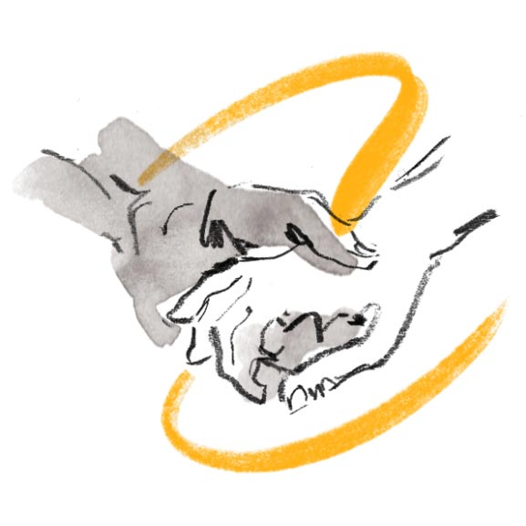
Ask your Pastor and Council President what they’re doing to join or host a pennies-on-the-dollar fundraiser for medical-debt relief. Learn more at bannerblue.org/herohospital.
You’re getting so smart! It’s time to answer the big question:
What should you do if you experience an illness or disability?
_______________________________________________________________________
_______________________________________________________________________
_______________________________________________________________________
_______________________________________________________________________
You are already building a place for hope within Jesus’ vision of God’s Kingdom. From Luke 8:40-56 we hear the good news, “Jesus said, “Daughter, now you’re healed and whole. Go in Peace. Live well, live blessed!” Take things to the next level by answering this open-ended question:
Who can you go to for help in times of need (list the people at home, at school, at church)?
Do you feel like you can go to God for help?
_______________________________________________________________________
_______________________________________________________________________
_______________________________________________________________________
_______________________________________________________________________
Give yourself a on your “I’m Awesome” pages for building.

This is the back of the “I’m Awesome” Poster. You can keep this poster in the Builder Book or remove it.

This is the back of the “I’m Awesome” Poster. You can keep this poster in the Builder Book or remove it.

Building a place for…
It’s time to learn about Susan and her story as well as Jesus and his story. Check out the graphic on the next page or at bannerblue.org/herohospital. Once you have learned about Susan, award her Builder Bricks by putting stickers on the Susan’s Awesome page (33) for all the things she did to build up Jesus’ vision of the Kingdom of God.
Bricks may be awarded for things like this:
One brick for every example from the story about music.
One brick for every example of making something or being creative.
One brick for every example of learning and exploring ideas.
One brick for being a good example and leading the way.
One brick for accomplishing something new in life.
Two bricks for bringing healing to others.
One brick for anything else you can think of.
Susan Le Flesche Picotte’s Story
Native American  Susan was born in 1865 on the Omaha Reservation in Nebraska, U.S.A. | 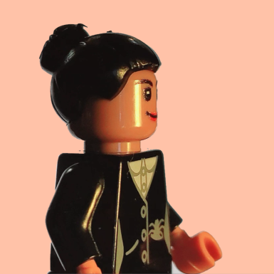 |  | Girl  Susan had three siblings and was the youngest.
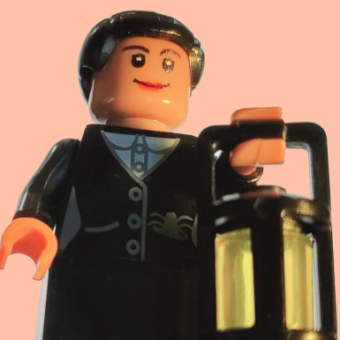 |  | First Native American Doctor  Susan studied really hard and became the first doctor in the United States whose people lived here long before there was a U.S. | 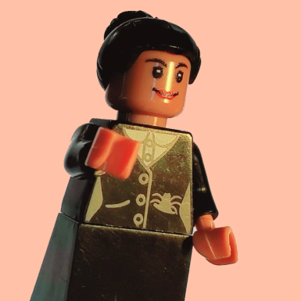 |  | Family  Susan learned a lot from her dad, Omaha Chief Iron Eye, and returned to be with her family after medical school.
Faithful  Susan read the Bible and believed that healing people was a mission given to her by God. |  |  | Really Good Doctor Susan was so good at helping people get better that other doctors became jealous that people came from far away to see her.
 |  | Really Really Good Doctor  Susan often travelled long distances herself to bring healing to people in remote places. | 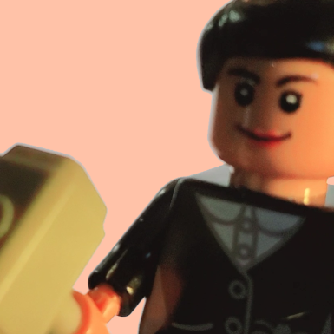 |  | Built a Hospital  Susan raised the money to build a brand-new hospital for her people.
Difficult People  Susan worked with a lot of difficult people who thought she was wrong to help others or wasn’t doing it the right way, but this never stopped her. |  |  | Understood Loss  Even though Susan was so good at helping and healing, her husband died of disease and she had to deal with that loss. | 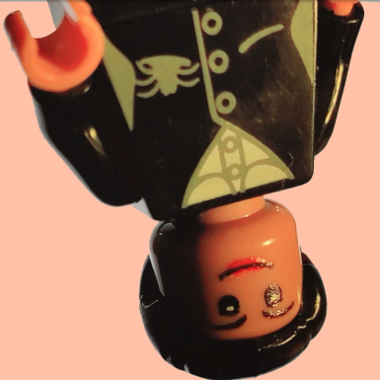

Jesus’ Story
“I know one thing for sure: that though I was blind, now I see. I came into the clear light of day.” From John 9:1-41
Jesus and his disciples were walking along when they saw a man born blind, and the disciples wondered if he or his parents did something to deserve the blindness. | 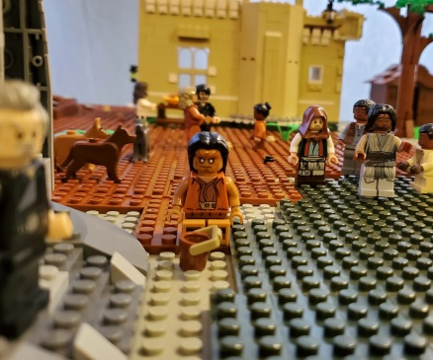 |  | Jesus said, “Neither! That’s not how it works with a God who loves us so much!” | 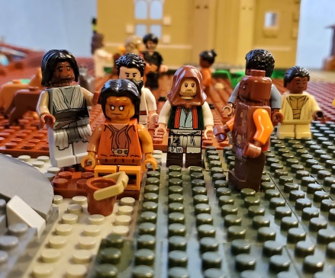
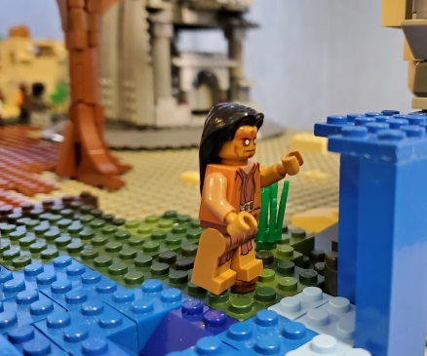 |  | Jesus had the man wash himself and because he trusted Jesus, he could suddenly see. | 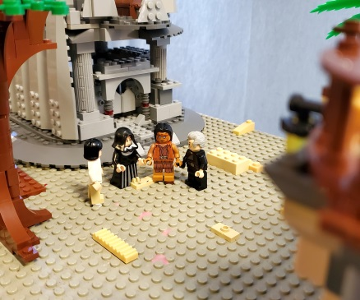 |  | When others found the man able to see, they couldn’t believe that it was really him, but he insisted it was really him and explained that Jesus had helped him.
Some temple leaders questioned him about how he could see, and they didn’t believe his story. | 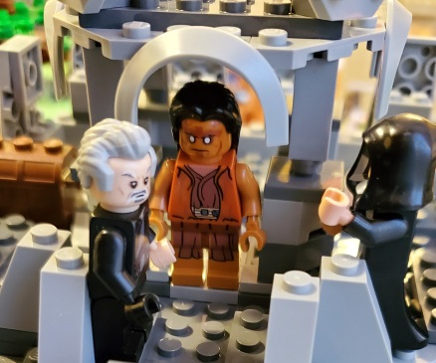 |  | They even brought in his parents so they could be sure he had been born with blindness. | 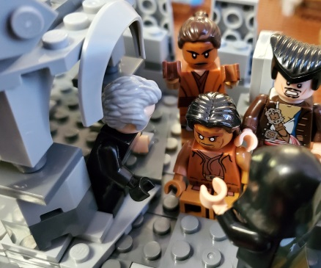
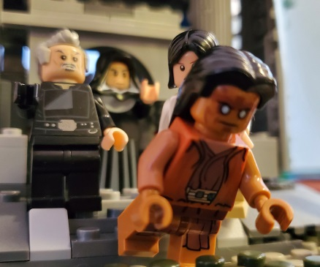 |  | The people still couldn’t wrap their heads around things, but the man declared his faith in Jesus so they kicked him out of the temple. | 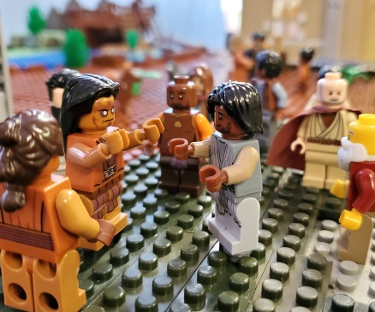 |  | Jesus heard about this and found the man, and revealed to him that he was the messiah. The man believed.
Jesus’ disciples make some bad assumptions about a man who was born with blindness. When Jesus helps the man, everyone seems to make the same bad assumption that he deserved blindness. Jesus proves them all wrong with God’s love.
Your Story
Now it’s time to award Builder Bricks to yourself and your friends. How many ways can you connect to Jesus’ or Susan’s story? What are gifts you have and things you do to help build Jesus’ vision of God’s Kingdom?
Go to your “I’m Awesome” pages and award bricks for things like this:
One brick for every example from the story about music.
One brick for every example of making something or being creative.
One brick for every example of learning and exploring ideas.
One brick for being a good example and leading the way.
One brick for accomplishing something new in life.
Two bricks for bringing healing to others.
Two bricks for following Jesus and helping people like he did.
One brick for any other way you’re like Susan or she’s like you.
Let’s Get Scientific!!!
Before you complete the Part Four science experiment, write down your hypothesis about what will happen:
If I use my imagination and skills to try to test sight, I will…
_______________________________________________________________________
_______________________________________________________________________
_______________________________________________________________________
_______________________________________________________________________
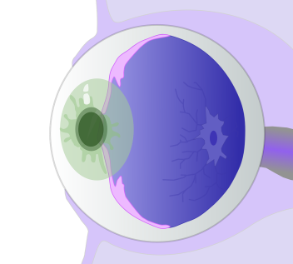
Now complete the investigation into The Miracles of Sight using the online guide at bannerblue.org/herohospital.

Next write about what will happen if you use your imagination and skills as a builder of Jesus’ vision of God’s Kingdom:
If I’m making our church into a place for healing, we will…
_______________________________________________________________________
_______________________________________________________________________
_______________________________________________________________________
_______________________________________________________________________
Give yourself a on your “I’m Awesome” pages for investigating.
Let’s Get Artistic!!!
Before you complete the Part Four art project, draw some ideas to help get you started:
If I use my imagination and skills to try to create Famous Frames, they might look something like this…

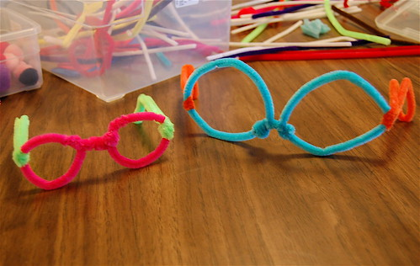
Now work on the Famous Frames using the online guide at bannerblue.org/herohospital.

Next draw what will happen if you use your imagination and skills as a builder of Jesus’ vision of God’s Kingdom:
If I’m making our church into a place for healing, we will…

Give yourself a on your “I’m Awesome” pages for creating.
Let’s Play a Game!!!
Have fun with family or friends using the
for Connect Four or Jenga.
Find these rules and an alternate tag game on bannerblue.org/herohospital.
Give yourself a on your “I’m Awesome” pages for playing.
Let’s Change the World!!!
Starting in Your Own Community
You’ve been working hard using your imagination and skills to build Jesus’ vision of God’s Kingdom. The leaders at your church should be doing that too! You all have been given a Big Church Project. It’s time for you to be a leader in making that project happen!
Ask your Pastor and Council President what they’re doing to collect and donate gently-used glasses or raise funds for cataract surgeries. Learn more at bannerblue.org/herohospital.

You’re getting so smart! It’s time to answer the big question:
Why do some people experience an illness or disability when others don’t?
_______________________________________________________________________
_______________________________________________________________________
_______________________________________________________________________
_______________________________________________________________________
You are already building a place for healing within Jesus’ vision of God’s Kingdom. From John 9:1-41 we hear the good news, “I know one thing for sure: that though I was blind, now I see. I came into the clear light of day.” Take things to the next level by answering this open-ended question:
What can you say to someone who is feeling awful to help them heal?
How can you also show that kind of love?
_______________________________________________________________________
_______________________________________________________________________
_______________________________________________________________________
_______________________________________________________________________
Give yourself a on your “I’m Awesome” pages for building.
Building a place for…
It’s time to learn about Hildegard and her story as well as Jesus and his story. Check out the graphic on the next page or at bannerblue.org/herohospital. Once you have learned about Hildegard, award her Builder Bricks by putting stickers on the Hildegard’s Awesome page (43) for all the things she did to build up Jesus’ vision of the Kingdom of God.
Bricks may be awarded for things like this:
One brick for every example from the story about music.
One brick for every example of making something or being creative.
One brick for every example of learning and exploring ideas.
One brick for being a good example and leading the way.
One brick for accomplishing something new in life.
Two bricks for being curious and exploring.
One brick for anything else you can think of.

Hildegard of Bingen’s Story
European  Hildegard was born in 1098 CE in Bermersheim vor der Höhe of the Holy Roman Empire (now Germany). | 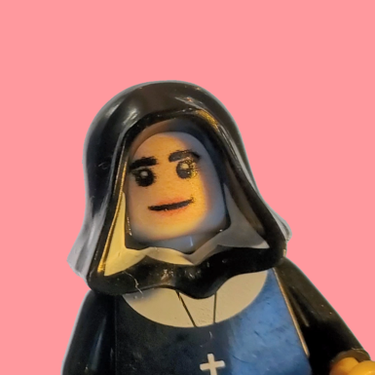 |  | Girl  Hildegard had nine siblings and she was the youngest. | 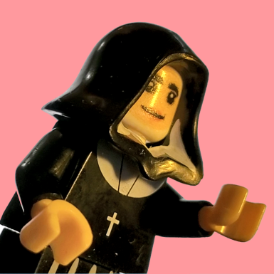
 |  | A Nun  Hildegard became a nun and dedicated her life to serving God. |  |  | Leader of an Abbey  Hildegard even became an Abbess that meant she led a whole community of nuns.
Famous Musician Hildegard is one of the first composers in the entire world which means she wrote lots of popular music. | 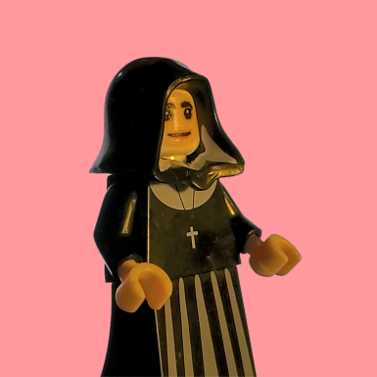 |  | Reader  Hildegard spent a lot of time reading books in her library and uncovered all kinds of discoveries about medicine. | 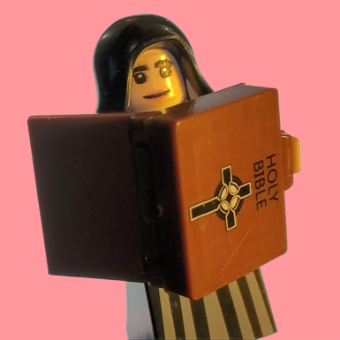
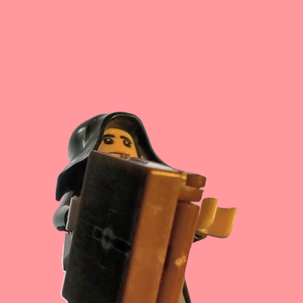 |  | Researcher  Hildegard carefully practiced using the medicines she learned about, which led to new discoveries. | 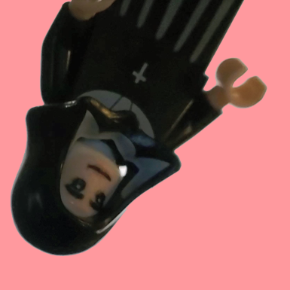 |  | Writer  Hildegard wrote many books that lots of people still read today and that are used in many schools.
Visionary  Hildegard received visions from God and shared them with people. | 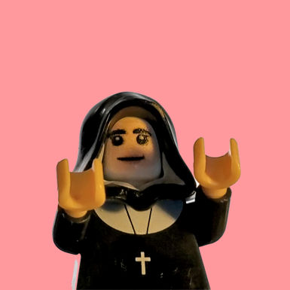 |  | Migraines  Hildegard’s visions also came with terrible migraines that she lived with her whole life. | 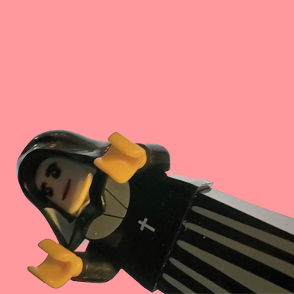
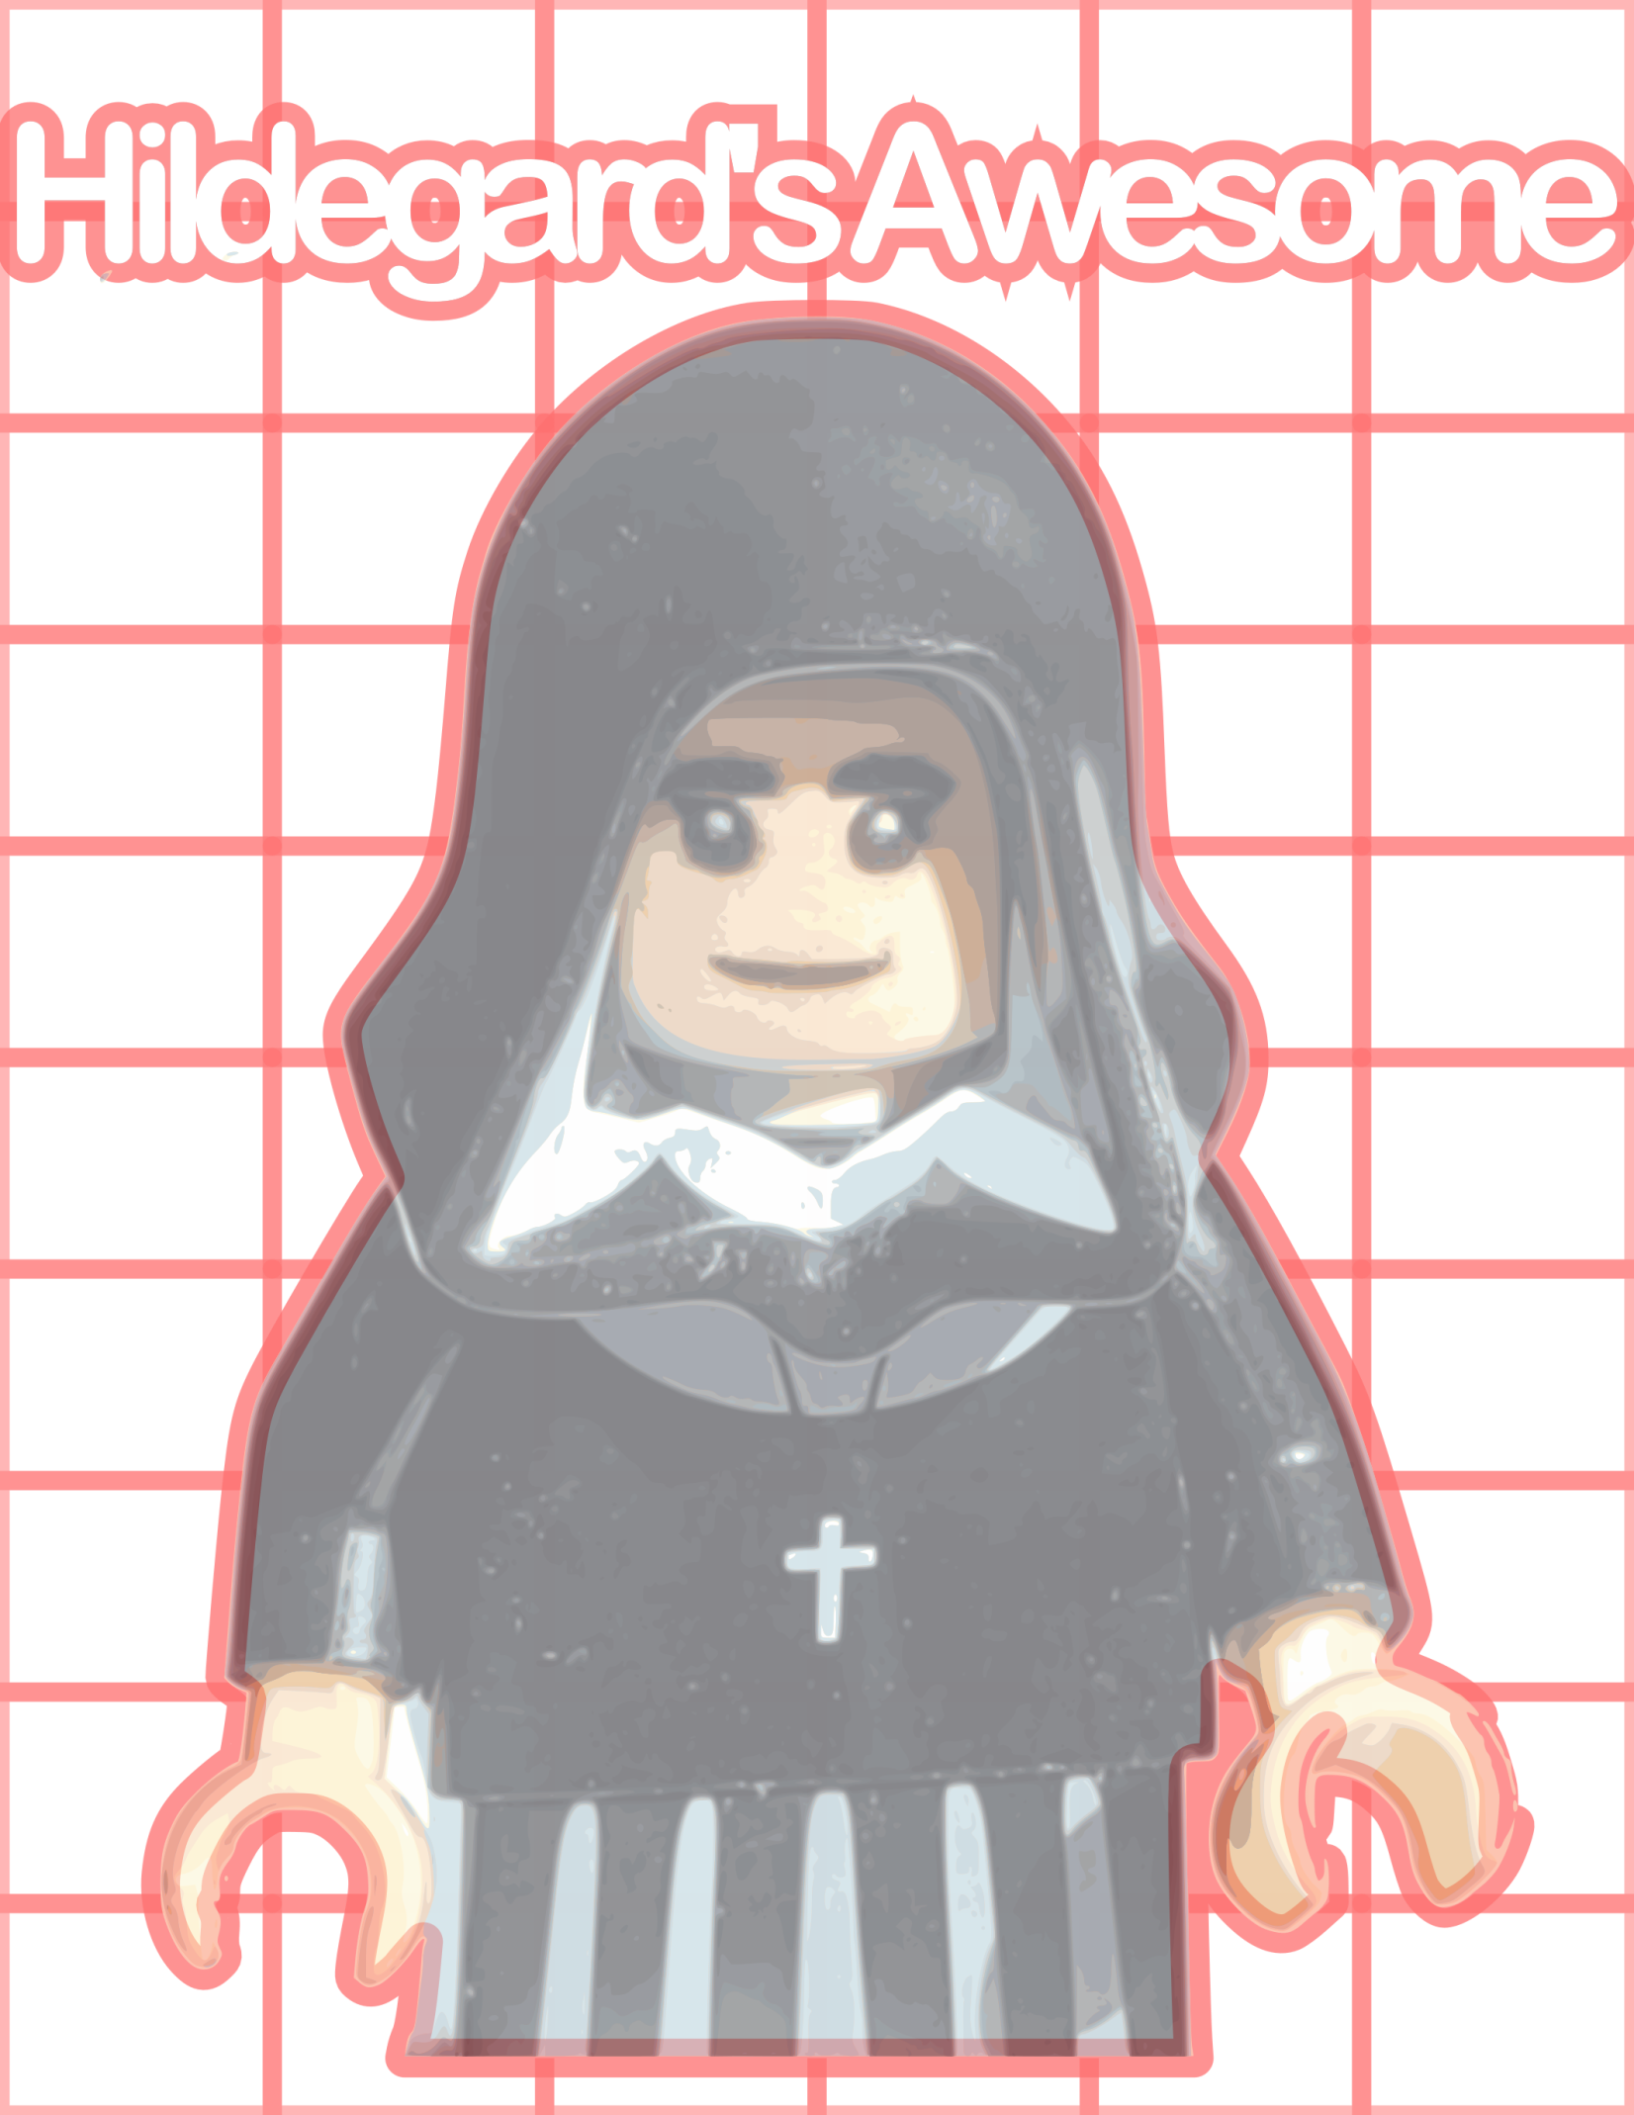

Jesus’ Story
“Jesus said, “the people are to know all about God—streaming in from the east, pouring in from the west, sitting down at God’s kingdom banquet.” From Matthew 8:1-13
Jesus finished teaching the people all about building God’s kingdom of justice and peace and came down from the mountain. | 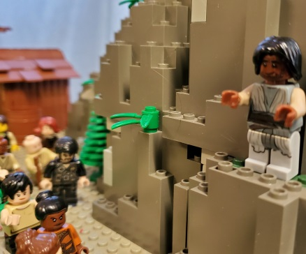 |  | A person living with leprosy came forward and asked for Jesus’ help, saying “Lord if you choose, make me clean.” | 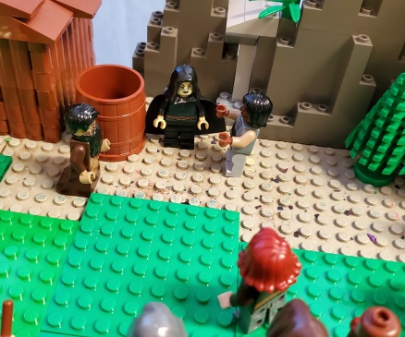
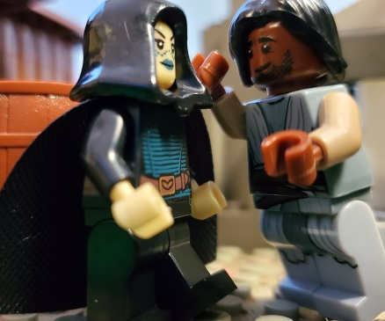 |  | Jesus said, “I do choose” and healed the person and sent them off to go thank God. | 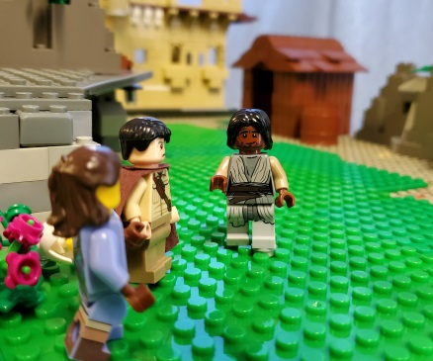 |  | Then a Roman Officer came up to Jesus and asked for help with his servant who lived with paralysis.
Jesus offered to go to the servant but the officer said he wasn’t worthy to have Jesus in his home and that he believed Jesus could simply say the words and the servant would be healed. | 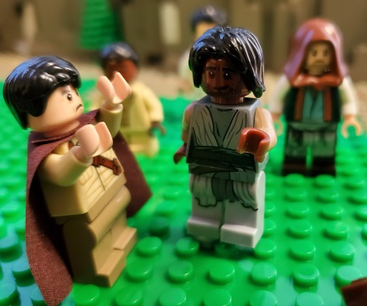 |  | Jesus was really impressed by the officer’s faith, especially because he was new to trusting in God. | 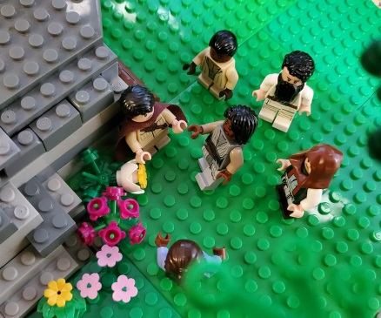
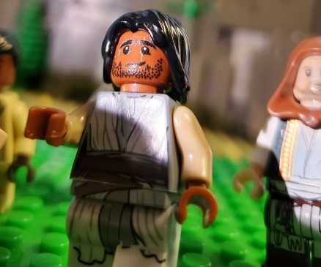 |  | Jesus said that the servant was healed. | 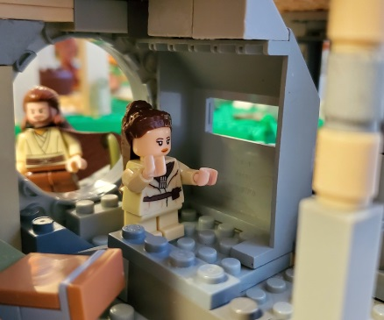 |  | Suddenly, across town  the servant was healed  and well.
You can also watch the video of this story at bannerblue.org/herohospital.
Jesus helps a man experiencing leprosy and a servant experiencing paralysis. Jesus is amazed that the man is so ready to believe in him. Jesus is glad that the servant’s boss cared so much and understood Jesus’ power so well.
Your Story
Now it’s time to award Builder Bricks to yourself and your friends. How many ways can you connect to Jesus’ or Hildegard’s story? What are gifts you have and things you do to help build Jesus’ vision of God’s Kingdom?
Go to your “I’m Awesome” pages and award bricks for things like this:
One brick for every example from the story about music.
One brick for every example of making something or being creative.
One brick for every example of learning and exploring ideas.
One brick for being a good example and leading the way.
One brick for accomplishing something new in life.
Two bricks for being curious and exploring.
Two bricks for following Jesus and helping people like he did.
One brick for any other way you’re like Hildegard or she’s like you.
Let’s Get Scientific!!!
Before you complete the Part Five science experiment, write down your hypothesis about what will happen:
If I use my imagination and skills to try to test heartrates, I will…
_______________________________________________________________________
_______________________________________________________________________
_______________________________________________________________________
_______________________________________________________________________
Now complete the investigation into Get Your Heart Pumping using the online guide at bannerblue.org/herohospital.

Next write about what will happen if you use your imagination and skills as a builder of Jesus’ vision of God’s Kingdom:
If I’m making our church into a place for discovery, we will…
_______________________________________________________________________
_______________________________________________________________________
_______________________________________________________________________
_______________________________________________________________________
Give yourself a on your “I’m Awesome” pages for investigating.
Let’s Get Artistic!!!
Before you complete the Part Five art project, draw some ideas to help get you started:
If I use my imagination and skills to try to create Blood Donor Stickers, they might look something like this…

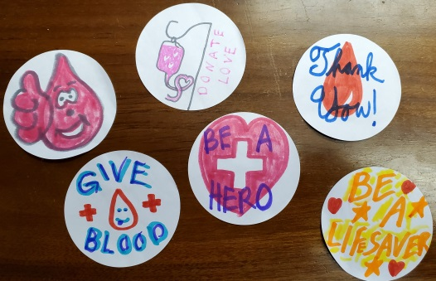
Now work on the Blood Donor Stickers using the online guide at bannerblue.org/herohospital.

Next draw what will happen if you use your imagination and skills as a builder of Jesus’ vision of God’s Kingdom:
If I’m making our church into a place for discovery, we will…

Give yourself a on your “I’m Awesome” pages for creating.
Let’s Play a Game!!!
Have fun with family or friends using the
for Candy Land or Clue.
Find these rules and an alternate tag game on bannerblue.org/herohospital.
Give yourself a on your “I’m Awesome” pages for playing.
Let’s Change the World!!!
Starting in Your Own Community
You’ve been working hard using your imagination and skills to build Jesus’ vision of God’s Kingdom. The leaders at your church should be doing that too! You all have been given a Big Church Project. It’s time for you to be a leader in making that project happen!
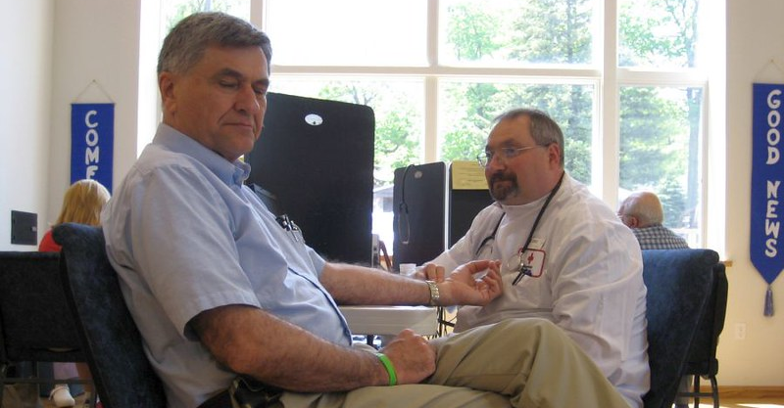
Ask your Pastor and Council President what they’re doing to hold a community blood drive at your church and get lots of donors. Learn more at bannerblue.org/herohospital.

You’re getting so smart! It’s time to answer the big question:
Why do some people recover from an illness or disability when others don’t?
_______________________________________________________________________
_______________________________________________________________________
_______________________________________________________________________
_______________________________________________________________________
You are already building a place for discovery within Jesus’ vision of God’s Kingdom. From Matthew 8:1-13 we hear the good news, “Jesus said, “the people are to know all about God—streaming in from the east, pouring in from the west, sitting down at God’s kingdom banquet.” Take things to the next level by answering this open-ended question:
What have you learned about recovering from or living with a challenging condition?
_______________________________________________________________________
_______________________________________________________________________
_______________________________________________________________________
_______________________________________________________________________
Give yourself a on your “I’m Awesome” pages for building.

Building a place for…
It’s time to learn about Cecilia and her story as well as Jesus and his story. Check out the graphic on the next page or at bannerblue.org/herohospital. Once you have learned about Cecilia, award her Builder Bricks by putting stickers on the Cecilia’s Awesome page (53) for all the things she did to build up Jesus’ vision of the Kingdom of God.
Bricks may be awarded for things like this:
One brick for every example from the story about music.
One brick for every example of making something or being creative.
One brick for every example of learning and exploring ideas.
One brick for being a good example and leading the way.
One brick for accomplishing something new in life.
Two bricks for doing something to praise God.
One brick for anything else you can think of.
Cecilia Makiwane’s Story
Black African  Cecilia was born in 1880 in Victoria District of South Africa. | 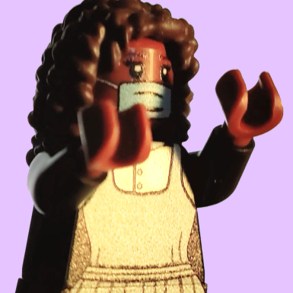 |  | Girl  Cicilia had two siblings and she was the middle child. | 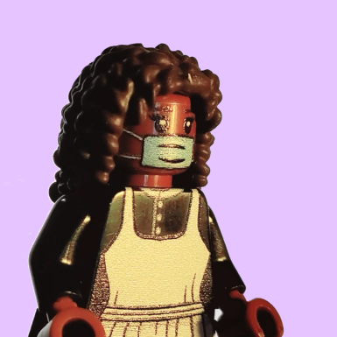
 |  | Went to School  Cecilia was one of only two African girls in her entire class so she probably felt really different at school. | 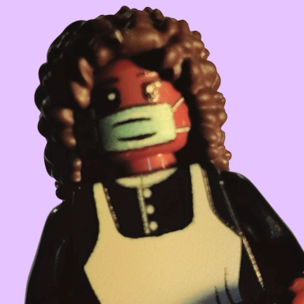 |  | First African Nurse Cecilia became the first nurse in all of Africa who was black.
Family  Cecilia was close with her sister who happened to be the first female African mathematician. | 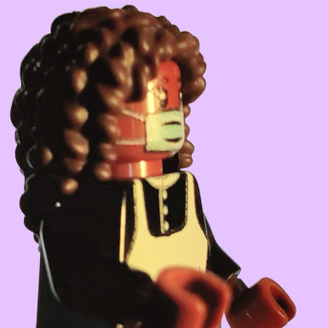 |  | Church Family  Cecilia’s dad was a pastor and she lived her life to give glory to God. | 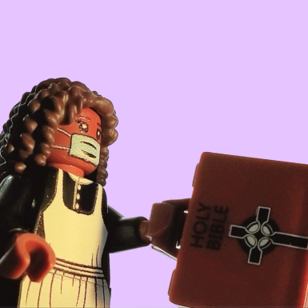
 |  | Fought for Justice Cecilia worked with other women to fight against racist laws in her country by organizing peaceful protests and marches. | 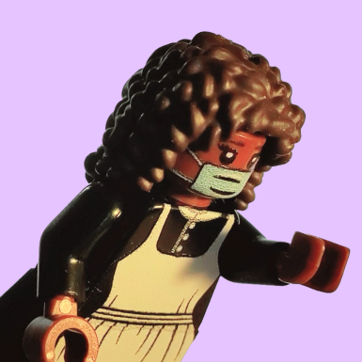 |  | Inspiration  Cecilia inspired many other people to become nurses and to fight for justice. She was even put on a stamp.
Got Really Sick  Cecilia became really sick and unfortunately, she never recovered. Cecilia was so sick she had to stop working and died. |  |  | Hospital in Her Honor An amazing hospital was built and then recently rebuilt in her honor--although Cecilia would probably pass the praise on to God. | 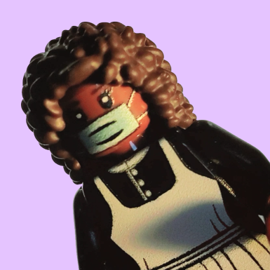
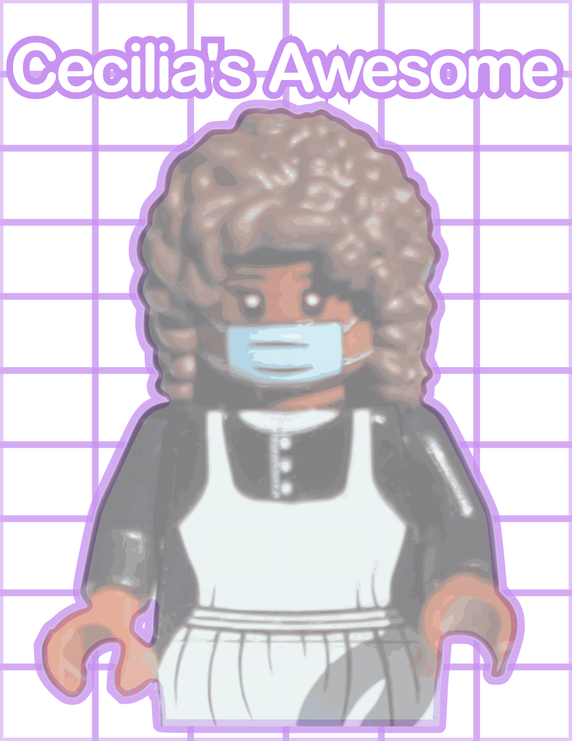

Jesus’ Story
“And the entire crowd was delighted and cheered, rejoicing at all the wonderful things that he was doing.” From Luke 13:10-17
One day, Jesus was teaching at the temple. | 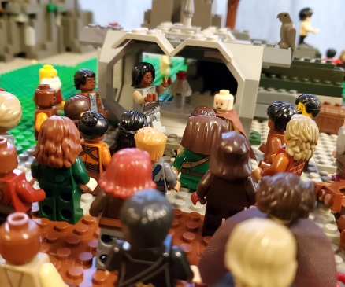 |  | A woman came in who had been bent over for 18 years. | 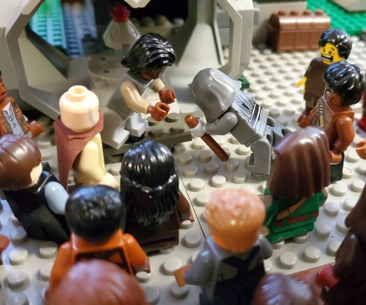
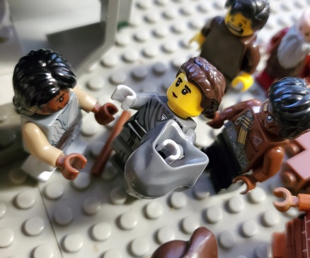 |  | Jesus welcomed her and helped without delay. | 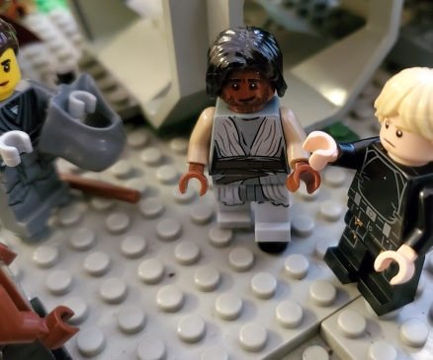 |  | The leader of the temple was outraged that Jesus had done this when he technically wasn’t supposed to be healing.
Jesus was having none of that; he reminded people how precious this woman was to God. | 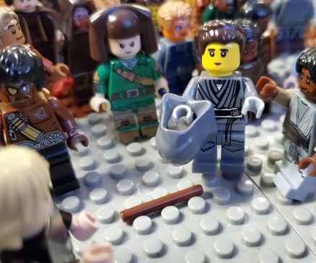 |  | She wanted to no longer live with her disability and so Jesus took it away. | 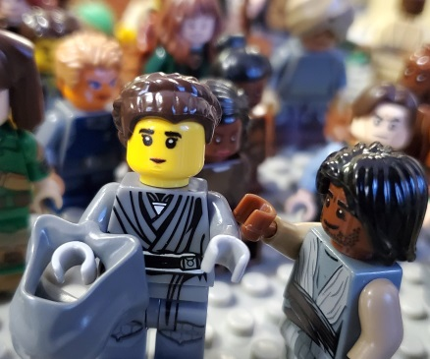
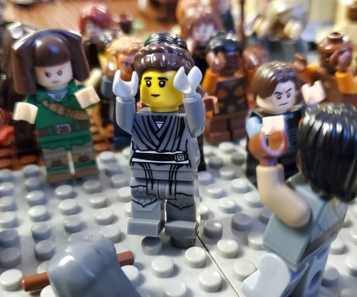 |  | Everyone started cheering and praising God! | 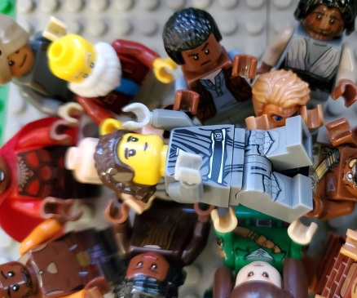 |  | The people and the woman would never forget how Jesus taught them to praise God by helping others.
Jesus helps a woman living with a disability by allowing for her to walk upright for the first time in 18 years. The people praised God for what Jesus had done for her and their community.
Your Story
Now it’s time to award Builder Bricks to yourself and your friends. How many ways can you connect to Jesus’ or Cecilia’s story? What are gifts you have and things you do to help build Jesus’ vision of God’s Kingdom?
Go to your “I’m Awesome” pages and award bricks for things like this:
One brick for every example from the story about music.
One brick for every example of making something or being creative.
One brick for every example of learning and exploring ideas.
One brick for being a good example and leading the way.
One brick for accomplishing something new in life.
Two bricks for doing something to praise God like Cecilia.
Two bricks for following Jesus and helping people like he did.
One brick for any other way you’re like Cecilia or she’s like you.

Let’s Get Scientific!!!
Before you complete the Part Six science experiment, write down your hypothesis about what will happen:
If I use my imagination and skills to try to test sleep, I will…
_______________________________________________________________________
_______________________________________________________________________
_______________________________________________________________________
_______________________________________________________________________

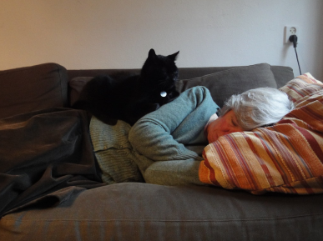
Now complete the investigation into Rest to Recharge using the online guide at bannerblue.org/herohospital.

Next write about what will happen if you use your imagination and skills as a builder of Jesus’ vision of God’s Kingdom:
If I’m making our church into a place for praise, we will…
_______________________________________________________________________
_______________________________________________________________________
_______________________________________________________________________
_______________________________________________________________________
Give yourself a on your “I’m Awesome” pages for investigating.
Let’s Get Artistic!!!
Before you complete the Part Six art project, draw some ideas to help get you started:
If I use my imagination and skills to try to create “You Rocks!!!”, they might look something like this…

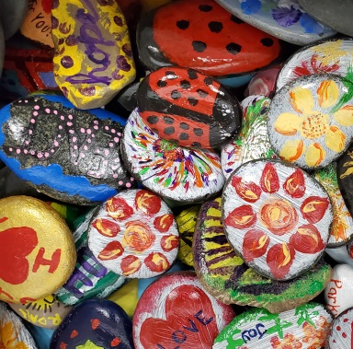
Now work on the “You Rocks!!!” using the online guide at bannerblue.org/herohospital.

Next draw what will happen if you use your imagination and skills as a builder of Jesus’ vision of God’s Kingdom:
If I’m making our church into a place for praise, we will…

Give yourself a on your “I’m Awesome” pages for creating.
Let’s Play a Game!!!
Have fun with family or friends using the
for Checkers or Battleship.
Find these rules and an alternate tag game on bannerblue.org/herohospital.
Give yourself a on your “I’m Awesome” pages for playing.
Let’s Change the World!!!
Starting in Your Own Community
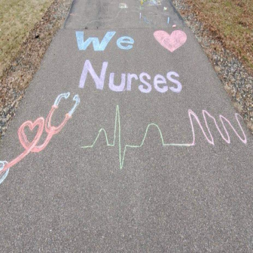
You’ve been working hard using your imagination and skills to build Jesus’ vision of God’s Kingdom. The leaders at your church should be doing that too! You all have been given a Big Church Project. It’s time for you to be a leader in making that project happen!
Ask your Pastor and Council President what they’re doing to #SupportHealthcareHeroes and to support frontline workers. Learn more at bannerblue.org/herohospital.

You’re getting so smart! It’s time to answer the big question:
How can you help those who care for people experiencing an illness or disability?
_______________________________________________________________________
_______________________________________________________________________
_______________________________________________________________________
_______________________________________________________________________
You are already building a place for all within Jesus’ vision of God’s Kingdom. From Luke 13:10-17 we hear the good news, “And the entire crowd was delighted and cheered, rejoicing at all the wonderful things that he was doing.” Take things to the next level by answering this open-ended question:
Who else in your community has been a helper and a hero during the pandemic?
And how can you support them?
_______________________________________________________________________
_______________________________________________________________________
_______________________________________________________________________
_______________________________________________________________________
Give yourself a on your “I’m Awesome” pages for building.

