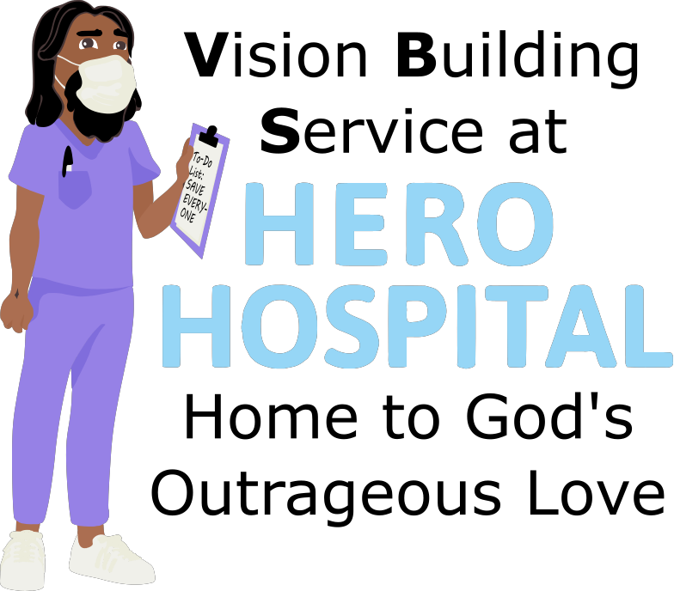
This week at Hero Hospital, we'll be learning that God's Kingdom is a
place for Healing!
Instructions for activities are found at: bannerblue.org/herohospital
In Story, we'll learn from our historical guide Susan and hear how Jesus offered healing in both body and spirit!
Provided Supplies: Builder Book and Builder Bricks.

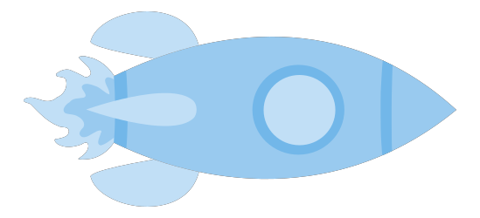
In Science, we'll explore the miracles of sight.
Provided Supplies: Builder Book and Builder Bricks.
Supplies from Home: Images on Hero Hospital website.
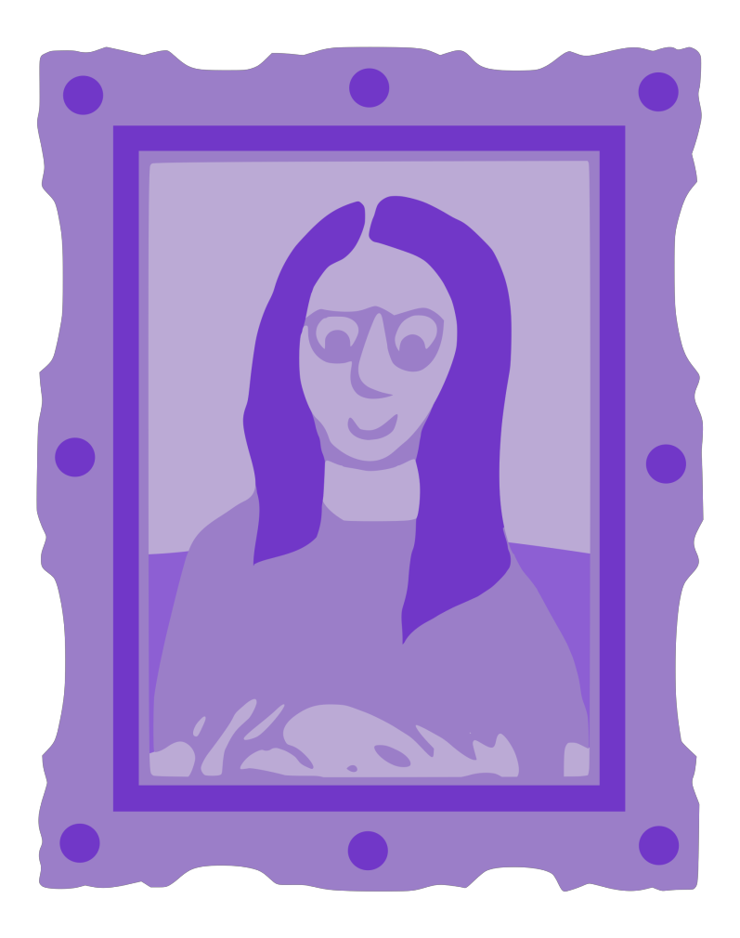
In Art, we’ll make our own famous frames.
Provided Supplies: Builder Book and Builder Bricks, pipe cleaners, foam shapes, pompoms, Example Sheet.
Supplies from Home: glue, scissors.
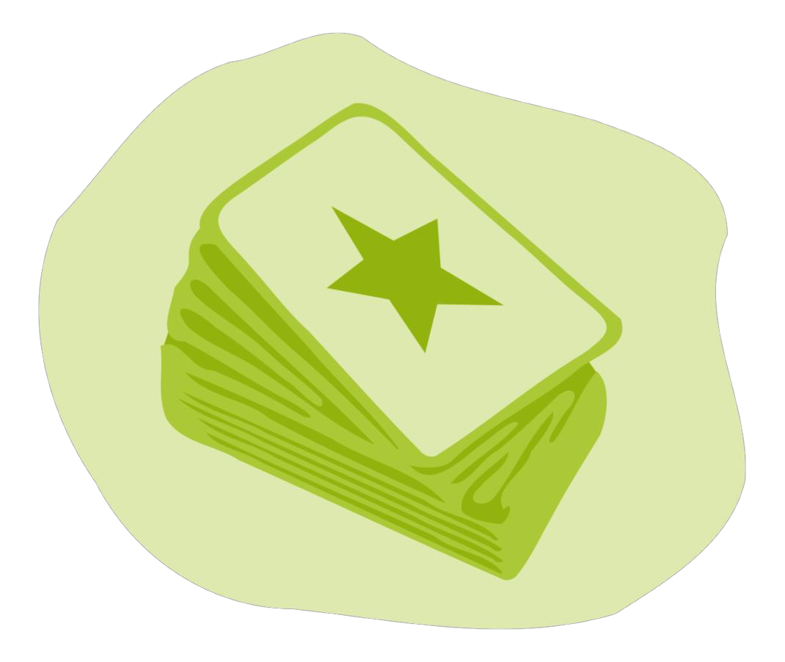
In Games, we’ll put a fun spin on Connect Four or Jenga by using the Gospel Rules! Or you can find a creative version of tag on the website.
Provided Supplies: Builder Book and Builder Bricks.
Supplies from Home: Connect Four or Jenga.

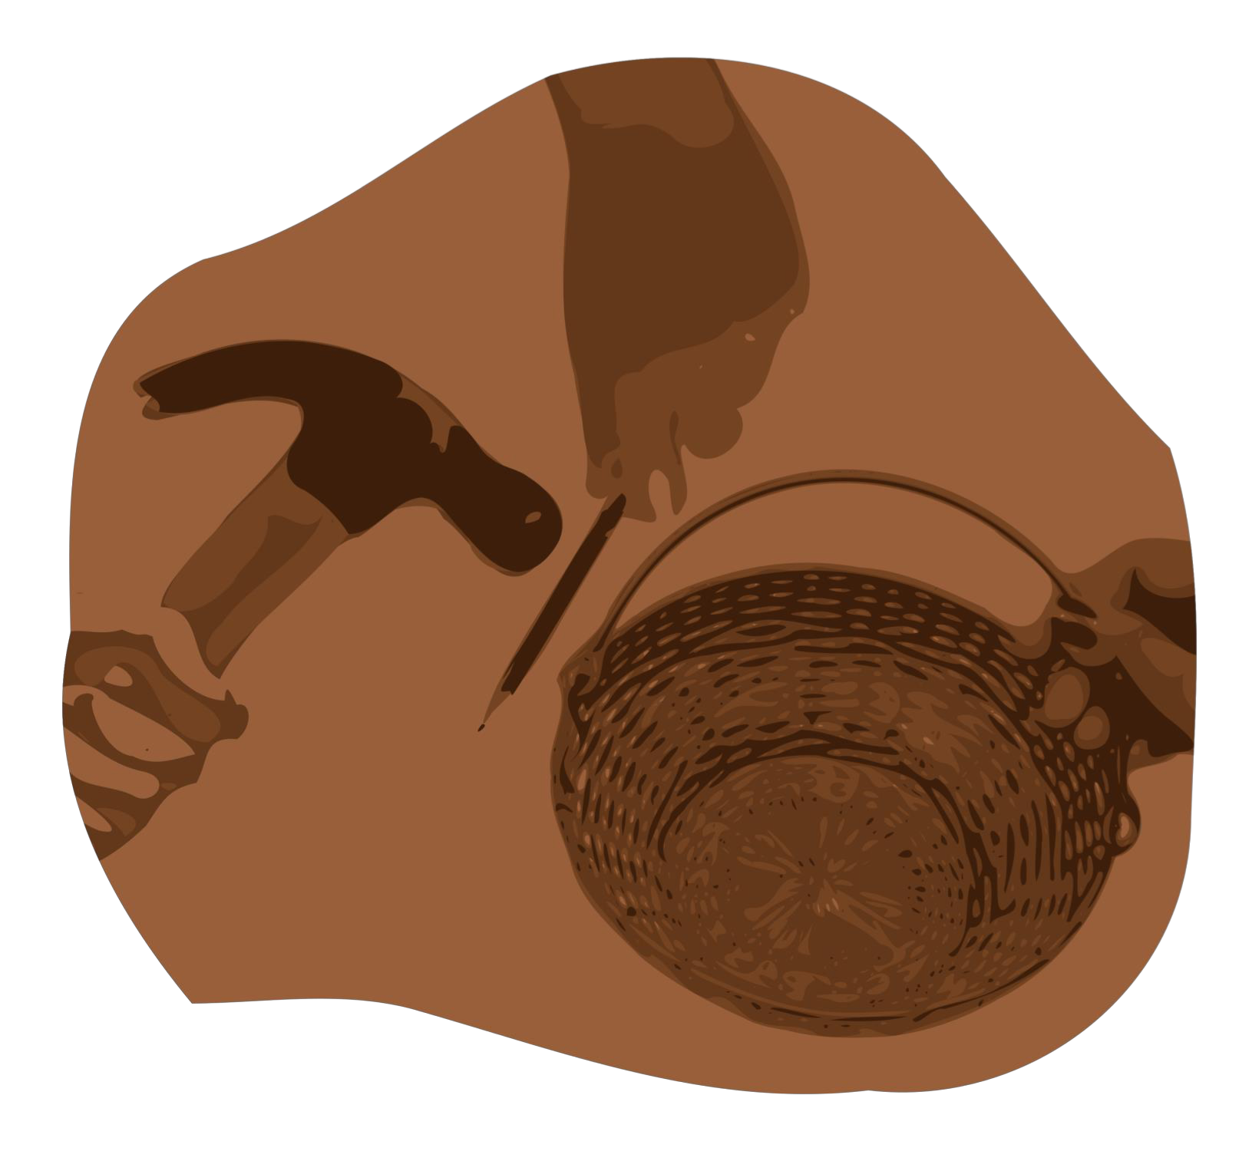
After learning about how Jesus wants us to make the world a better place by living out our faith, we’ll be inspired to do a Big Church Project! This week we’ll be inspired to collect eyeglasses that will be given to people around the world through the Lion’s Club. Kids are invited to ask Pastor Katie about this when they return next week!
Provided Supplies: Builder Book and Builder Bricks.
During Worship we’ll sing and dance along with our VBS Music. Kids can also listen to the Music on the Hero Hospital website.
Provided Supplies: Builder Book and Builder Bricks.

After sharing all of these activities and learning about faith during worship and at home with their families, our kids will be able to answer this week’s Big Question: Why do some people experience an illness or disability when others don’t?
Provided Supplies: Builder Book and Builder Bricks.

Remember to bring back your finished art and science activities for Show and Tell!

